Addition

Consistency of mental and written calculations for addition

Mental recall of number bonds
6 + 4 = 10  + 3 = 10
25 + 75 = 100 19 +  = 20

Use near doubles
6 + 7 = double 6 + 1 = 13

Addition using partitioning and recombining
34 + 45 = (30 + 40) + (4 + 5) = 79

Counting on or back in repeated steps of 1, 10, 100, 1000
86 + 57 = 143 (by counting on in tens and then in ones)
460 - 300 = 160 (by counting back in hundreds)

Add the nearest multiple of 10, 100 and 1000 and adjust
24 + 19 = 24 + 20 – 1 = 43
458 + 71 = 458 + 70 + 1 = 529

Use the relationship between addition and subtraction
36 + 19 = 55 19 + 36 = 55
55 – 19 = 36 55 – 36 = 19

MANY MENTAL CALCULATION STRATEGIES WILL CONTINUE TO BE USED.
THEY ARE NOT REPLACED BY WRITTEN METHODS.

Step 1

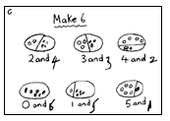
Pupils are encouraged to develop a mental picture of the number system in their heads to use for calculation. They develop ways of recording calculations using pictures, Numicon etc.
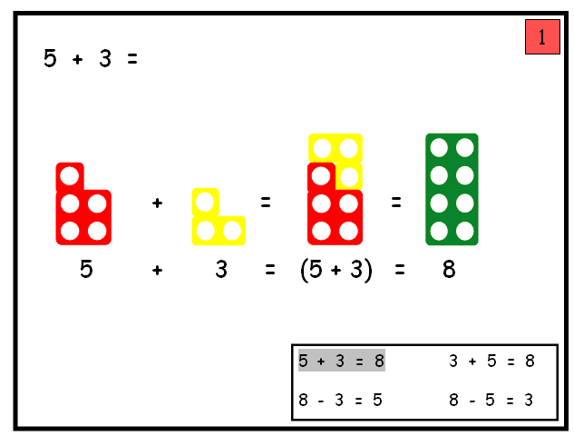

They use numberlines and practical resources to support calculation and teachers demonstrate the use of the numberline.

3 + 2 = 5
+1
+1

___________________________________________
0 1 2 3 4 5 6 7 8 9

Pupils then begin to use numbered lines to support their own calculations using a numbered line to count on in ones.

8 + 5 = 13
+1
+1
+1
+1
+1
0 1 2 3 4 5 6 7 8 9 10 11 12 13 14 15

Numicon plates, bead strings or bead bars can be used to illustrate addition including bridging through ten by counting on 2 then counting on 3.
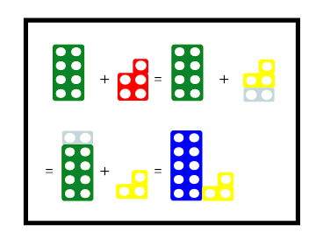

Step 2

Pupils will begin to use ‘empty number lines’ themselves starting with the larger number and counting on.

- First counting on in tens and ones.

34 + 23 = 57
+10
+10

+1
+1
+1

34 44 54 55 56 57

- Then helping pupils to become more efficient by adding the units in one jump (by using the known fact 4 + 3 = 7).

34 + 23 = 57
+10
+10

+3

34 44 54 57

- Followed by adding the tens in one jump and the units in one jump.

34 + 23 = 57
+20
+3

34 54 57

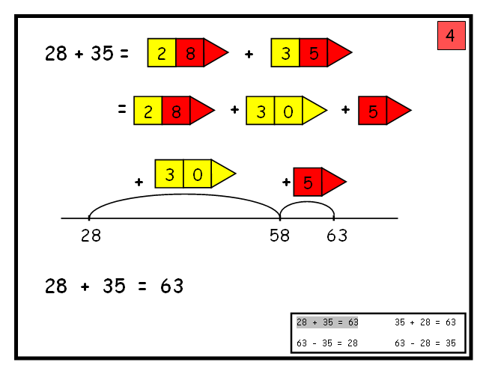

- Bridging through ten can help pupils become more efficient.

37 + 15 = 52
+10
+3
+2

37 47 50 52

Step 3

Pupils will continue to use empty number lines with increasingly large numbers, including compensation where appropriate.

- Count on from the largest number irrespective of the order of the calculation.

38 + 86 = 124
+30
+4
+4

86 116 120 124

- Compensation

49 + 73 = 122
+50

-1

73 122 123

Pupils will begin to use informal pencil and paper methods (jottings) to support record and explain partial mental methods building on existing mental strategies.

Phase 1 – Adding most significant digits first, and then moving to adding least significant digits.
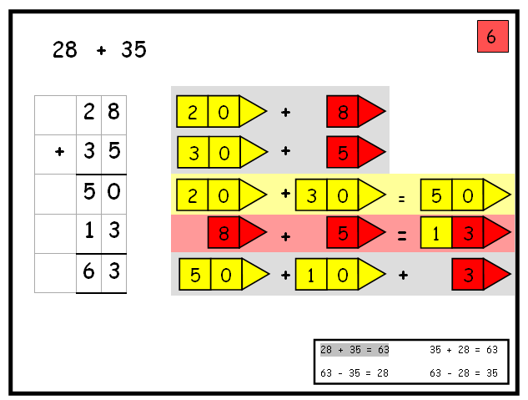

Phase 2 - Moving to adding the least significant digits first in preparation for ‘‘carrying’.
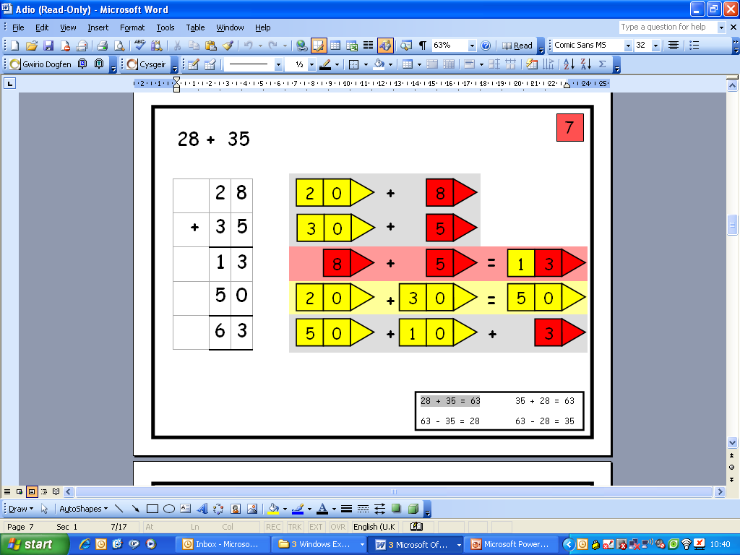

Adding the least significant digits first, without using place value cards

( 8 + 5)
(20 + 30)

Step 4
From this, pupils will begin to ‘‘carry’’ below the line, using the correct mathematical vocabulary.
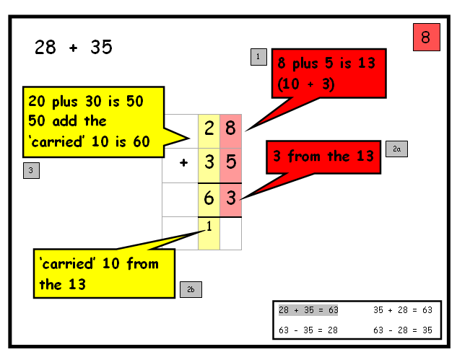

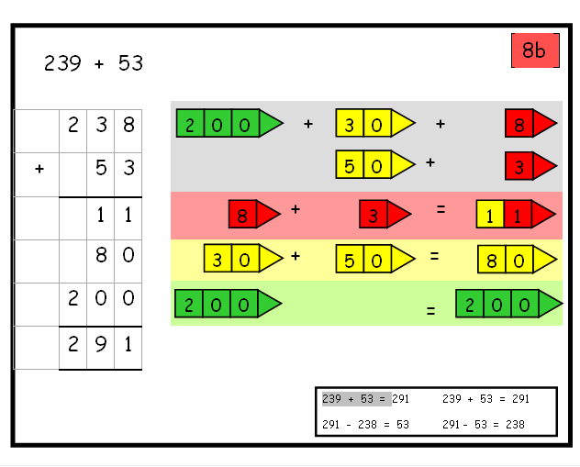
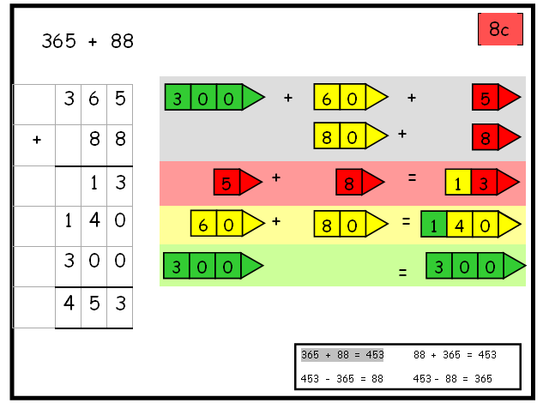
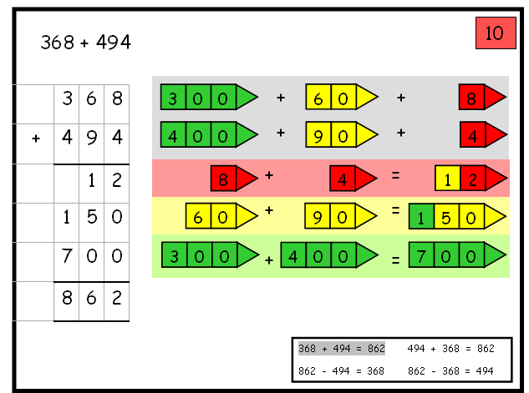

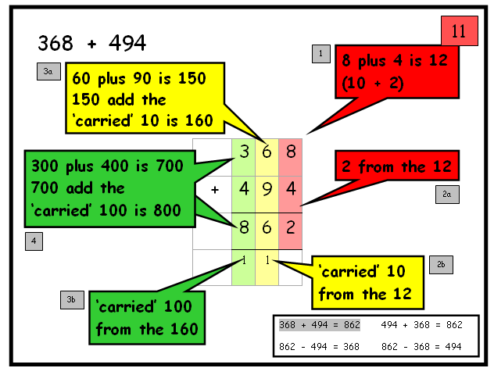

Using similar methods, pupils will:
- add several numbers with different numbers of digits;
- begin to add two or more three-digit sums of money, with or without adjustment from the pence to the pounds;
- know that the decimal points should line up under each other, particularly when adding or subtracting mixed amounts, e.g. £3.59 + 78p.

Step 5

Pupils should extend the ‘carrying’ method to numbers with at least four digits.

587 3587
+ 475 + 675
1062 4262
¹ ¹ ¹ ¹ ¹

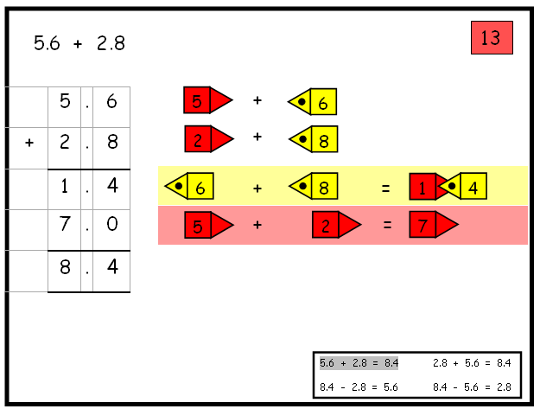
Pupils should extend their methods to decimal numbers.
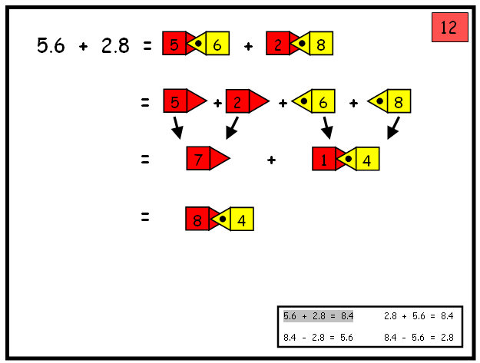
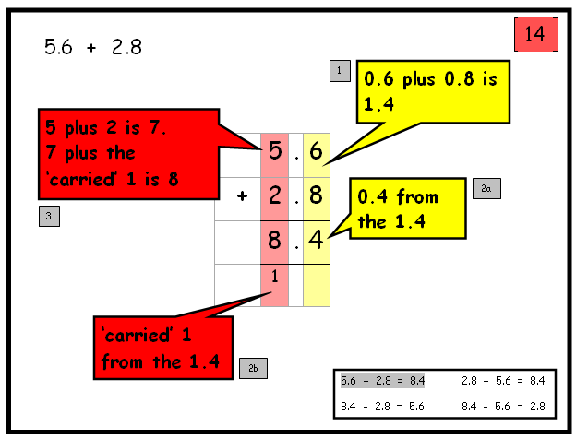

Using similar methods, pupils will:
- add several numbers with different numbers of digits;
- begin to add two or more decimal fractions with up to three digits and the same number of decimal places;
- know that decimal points should line up under each other, particularly when adding or subtracting mixed amounts, e.g. 3.2 m – 280 cm.

Step 6

Pupils should extend the ‘carrying’ method to number with any number of digits.

7648 6584 42
+ 1486 + 5848 6432
9134 12432 786
¹ ¹ ¹ ¹ ¹ ¹ 3
+ 4681 11944
¹ ² ¹

Using similar methods, pupils will
- add several numbers with different numbers of digits;
- begin to add two or more decimal fractions with up to four digits and either one or two decimal places;
- know that decimal points should line up under each other, particularly when adding or subtracting mixed amounts, e.g. 401.2 + 26.85 + 0.71.

Pupils need to have a range of calculation methods, mental and written. Selection will depend upon the numbers involved.

Pupils should not be made to go onto the next stage if:
1. they are not ready
2. they are not confident.

Pupils should be encouraged to approximate their answers before calculating.
Pupils should be encouraged to check their answers after calculation using an appropriate strategy.
Pupils should be encouraged to consider if a mental calculation would be appropriate before using written methods.

