YSGOL GYNRADD PENYRHEOL
PENYRHEOL PRIMARY SCHOOL

Putting Children First



Calculation Policy - Multiplication

MENTAL CALCULATIONS

Step 1

Doubling and halving
Applying the knowledge of doubles and halves to known facts.
e.g. 4 x 4 is double 2 x 4
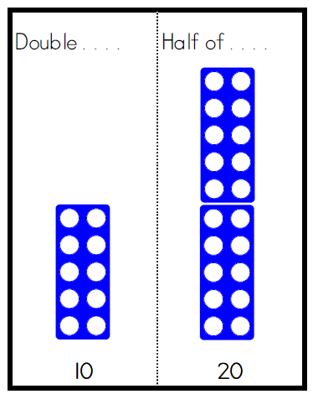
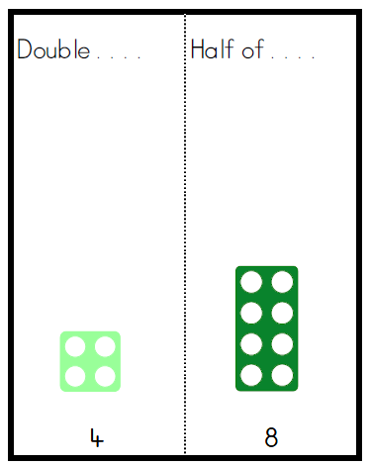

Multiplication Facts

Step 2
1 times table 1 times table
2 times table 10 times table
5 times table

0 1 2 3 4 5 6 7 8 9 10

0 2 4 6 8 10 12 14 16 18 20

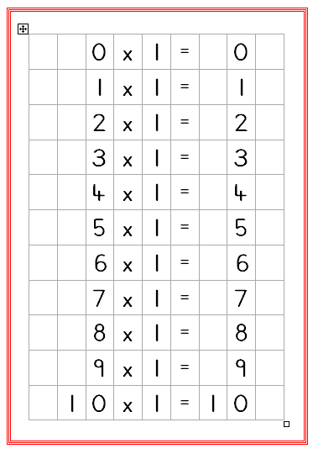
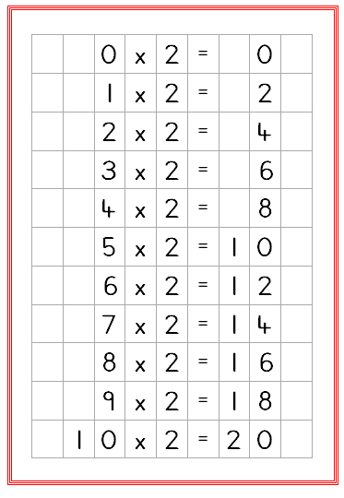

0 1 2 3 4 5 6 7 8 9 10

0 10 20 30 40 50 60 70 80 90 100

0 5 10 15 20 25 30 35 40 45 50

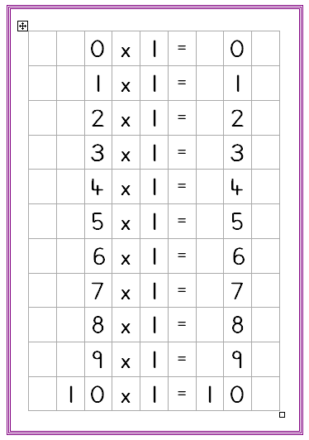
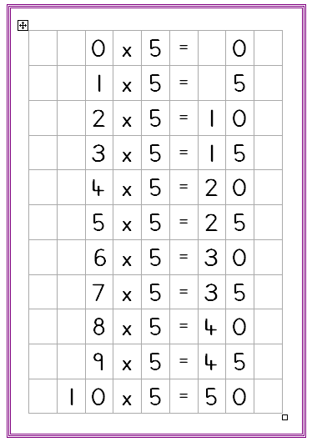
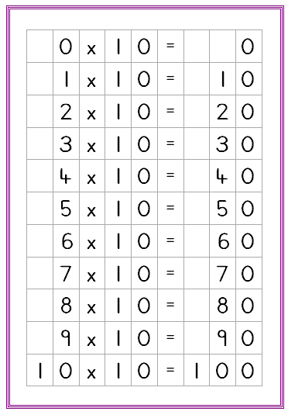

Step 3

1 times table 1 times table 1 times table
2 times table 10 times table 3 times table
4 times table 5 times table

0 1 2 3 4 5 6 7 8 9 10

0 2 4 6 8 10 12 14 16 18 20

0 4 8 12 16 20 24 28 32 36 40

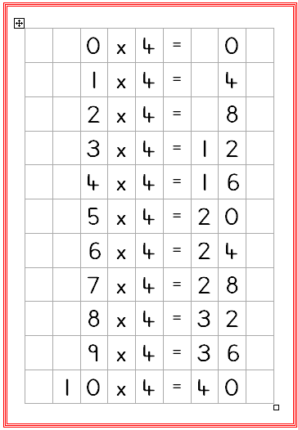

0 1 2 3 4 5 6 7 8 9 10

0 10 20 30 40 50 60 70 80 90 100

0 5 10 15 20 25 30 35 40 45 50

0 1 2 3 4 5 6 7 8 9 10

0 3 6 9 12 15 18 21 24 27 30

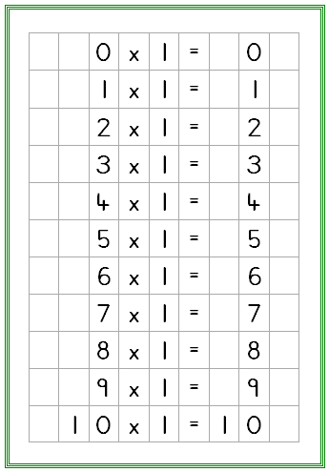
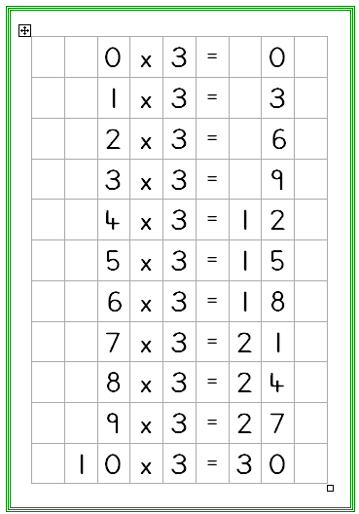

Step 4

1 times table 1 times table 1 times table
2 times table 10 times table 3 times table
4 times table 5 times table 6 times table

0 1 2 3 4 5 6 7 8 9 10

0 2 4 6 8 10 12 14 16 18 20

0 4 8 12 16 20 24 28 32 36 40

0 1 2 3 4 5 6 7 8 9 10

0 10 20 30 40 50 60 70 80 90 100

0 5 10 15 20 25 30 35 40 45 50

0 1 2 3 4 5 6 7 8 9 10

0 3 6 9 12 15 18 21 24 27 30

0 6 12 18 24 30 36 42 48 54 60

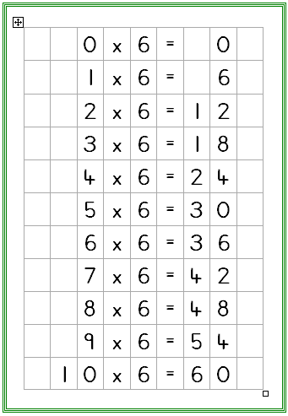

Step 5 Derive and recall quickly all multiplication facts up to 10 x 10.

1 times table 1 times table 1 times table 1 times table
2 times table 10 times table 3 times table 7 times table
4 times table 5 times table 6 times table
8 times table 9 times table

0 1 2 3 4 5 6 7 8 9 10

0 2 4 6 8 10 12 14 16 18 20

0 4 8 12 16 20 24 28 32 36 40

0 8 16 24 32 40 48 56 64 72 80

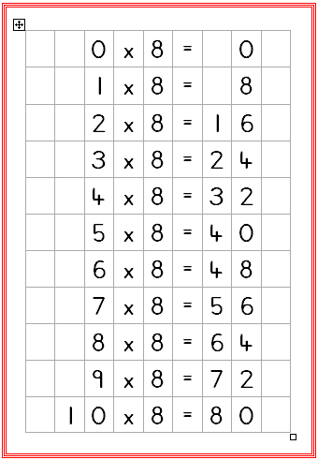

0 1 2 3 4 5 6 7 8 9 10

0 10 20 30 40 50 60 70 80 90 100

0 5 10 15 20 25 30 35 40 45 50

0 1 2 3 4 5 6 7 8 9 10

0 3 6 9 12 15 18 21 24 27 30

0 6 12 18 24 30 36 42 48 54 60

0 9 18 27 36 45 54 63 72 81 90

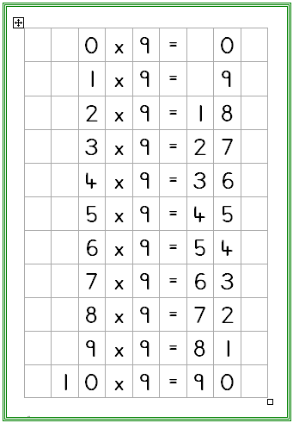

0 1 2 3 4 5 6 7 8 9 10

0 7 14 21 28 35 42 49 56 63 70

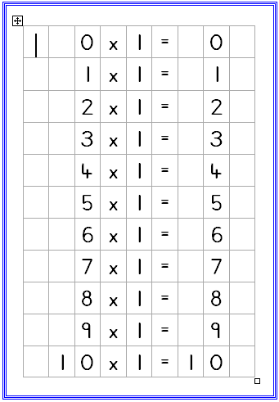
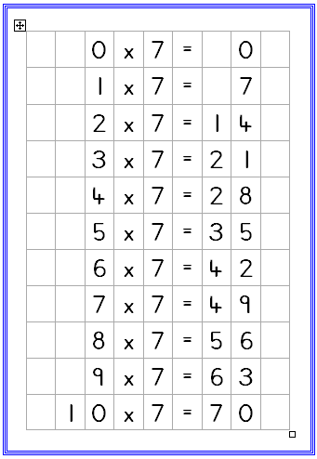

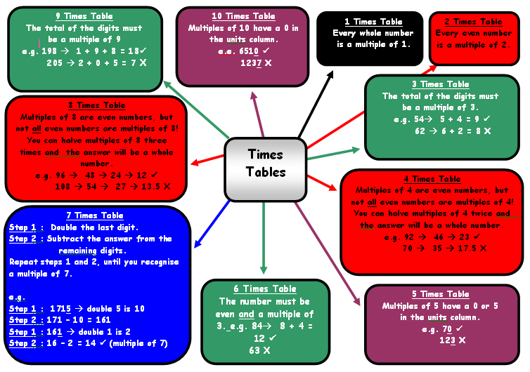

Step 6

Pupils should be able to utilise their tables’ knowledge to derive other facts.
E.g. If I know 3 x 7 = 21, what else do I know?

30 x 7 = 3 x 7 x 10 =210 300 x 7 = 3 x 7 x 10 x 10 = 3 x 7 x 100 = 2100

3000 x 7 = 3 x 7 x 10 x 10 x 10 = 3 x 7 x 10 x 100 = 3 x 7 x 1000 = 21 000

0.3 x 7 = (3 x 7 ) ÷ 10 = 2.1

Use closely related facts already known
13 x 11 = (13 x 10) + (13 x 1)
= 130 + 13
= 143

Multiplying by 10 or 100
Knowing that the effect of multiplying by 10 is the digit(s) moving one place to the left.
Knowing that the effect of multiplying by 100 is the digit(s) moving two places to the left.

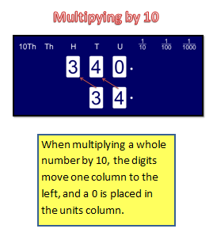
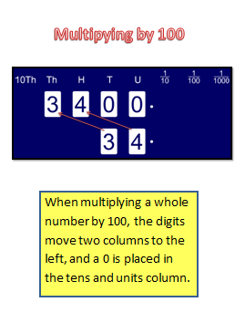

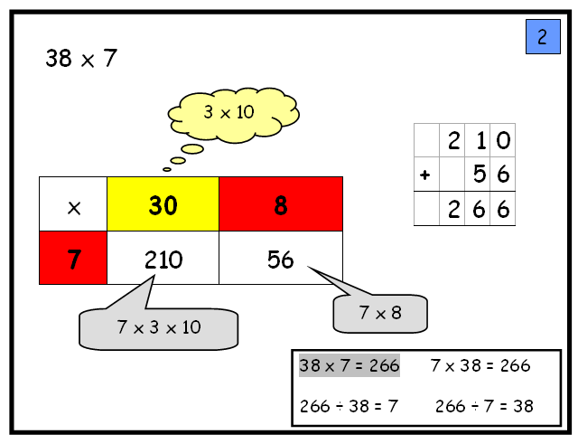
Partitioning
38 x 7 = (30 x 7) + (8 x 7)
= 210 + 56
= 266

Use of factors

11 x 50 = 11 x 5 x 10
11 x 5 = 55
55 x 10= 550
21 x 18 = 21 x 9 x 2
21 x 9 = 189
189 x 2 = 378

MANY MENTAL CALCULATION STRATEGIES WILL CONTINUE TO BE USED.
THEY ARE NOT REPLACED BY WRITTEN METHODS.
Step 1

Pupils will experience equal groups of objects and will count in 1s, 2s and 10s and begin to count in 5s. They will work on practical problem solving activities involving equal sets or groups.
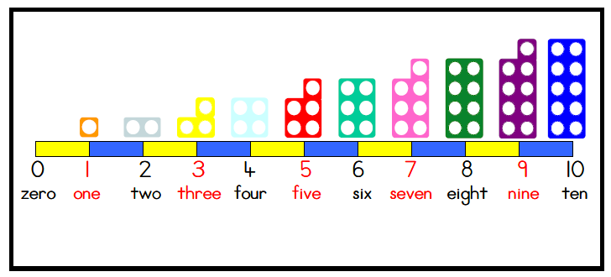

Step 2

Pupils will develop their understanding of multiplication and use jottings to support calculation:

- Repeated addition

3 times 5 is 5 + 5 + 5 = 15 or 3 lots of 5 or 5 x 3

Repeated addition can be shown easily on a number line:

5 x 3 = 5 + 5 + 5
5
5
5

0 1 2 3 4 5 6 7 8 9 10 11 12 13 14 15

and on a bead bar:

5 x 3 = 5 + 5 + 5
5
5
5

- Commutative

Pupils should know that 3 x 5 has the same answer as 5 x 3. This can also be shown on the number line.

5
5
5

0 1 2 3 4 5 6 7 8 9 10 11 12 13 14 15

3
3
3
3
3

- Arrays

Pupils should be able to model a multiplication calculation using an array. This knowledge will support with the development of the grid method.

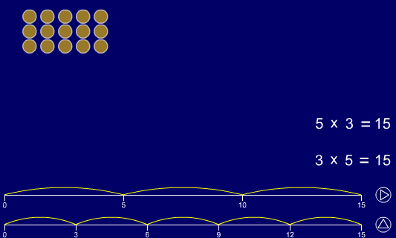
5 x 3 = 15

3 x 5 = 15

Step 3

Pupils will continue to use:

- Repeated addition

4 times 6 is 6 + 6 + 6 + 6 = 24 or 4 lots of 6 or 6 x 4

Pupils should use number lines or bead bars to support their understanding.

6
6
6
6

0 6 12 18 24
6
6
6
6

- Arrays

Children should be able to model a multiplication calculation using an array. This knowledge will support with the development of the grid method.

9 x 4 = 36

9 x 4 = 36

Pupils will also develop an understanding of

- Scaling

e.g. Find a ribbon that is 4 times as long as the blue ribbon

5 cm 20 cm

- Using symbols to stand for unknown numbers to complete equations using inverse operations

 x 5 = 20 3 x  = 18  x  = 32

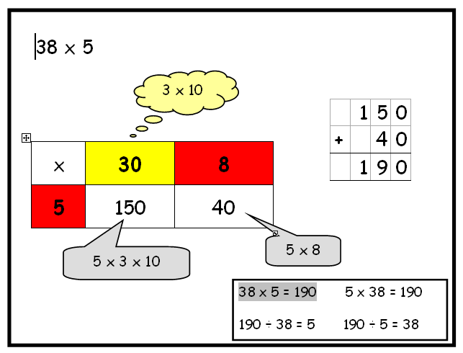
- Partitioning

38 x 5 = (30 x 5) + (8 x 5)
= 150 + 40
= 190

NNS Section 5 page 47

Step 4

Pupils will continue to use arrays where appropriate leading into the grid method of multiplication.

x 10 4
(6 x 10) + (6 x 4)

60 + 24

60
24
6
84

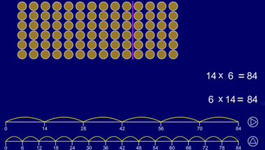

Grid method

TU x U
(Short multiplication – multiplication by a single digit)

23 x 8

Children will approximate first
23 x 8 is approximately 25 x 8 = 200

x | 20 | 3
8 | 160 | 24 |  |  | 160
 |  |  |  |  | + 24
 |  |  |  |  | 184
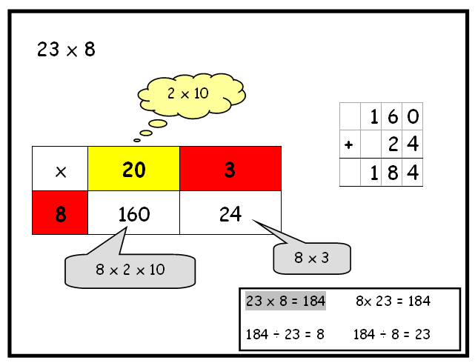

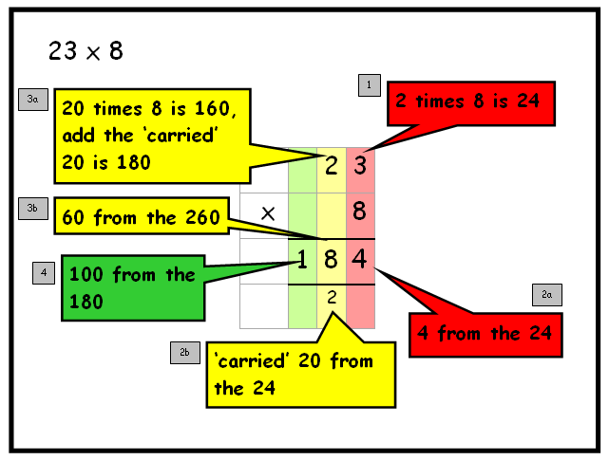

Step 5

Grid method

HTU x U
(Short multiplication – multiplication by a single digit)

346 x 9

Children will approximate first
346 x 9 is approximately 350 x 10 = 3500

x | 300 | 40 | 6
9 | 2700 | 360 | 54 |  |  | 2700
 |  |  |  |  |  | + 360
 |  |  |  |  |  | + 54
 |  |  |  |  |  | 31 1 4
 |  |  |  |  |  | 1 1

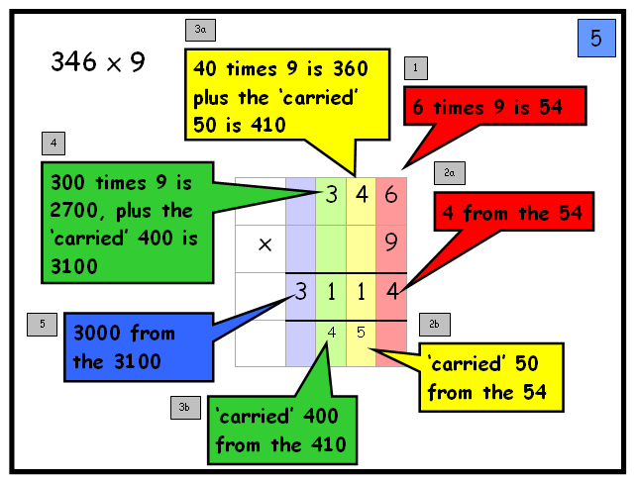

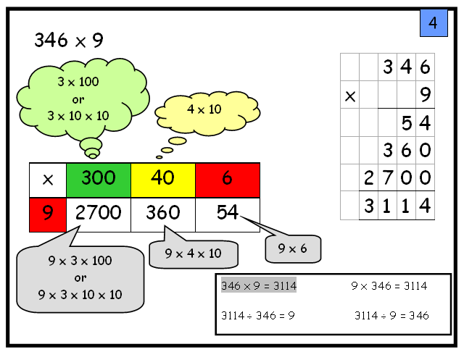

TU x TU
(Long multiplication – multiplication by more than a single digit)

56 x 27

Children will approximate first
56 x 27 is approximately 60 x 30 = 1800

x | 20 | 7
50 | 1000 | 350 |  |  | 1000
6 | 120 | 42 |  |  | + 350
 |  |  |  |  | + 120
 |  |  |  |  | + 42
 |  |  |  |  | 1512

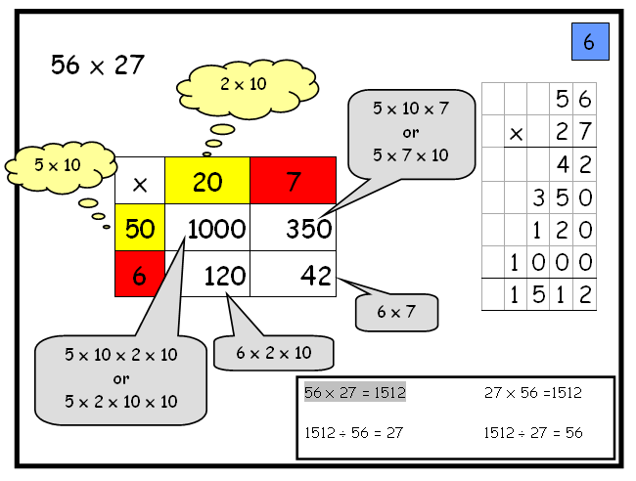

¹

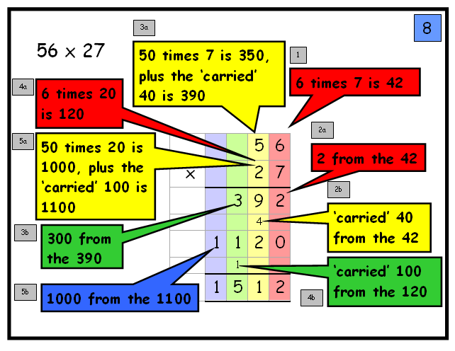
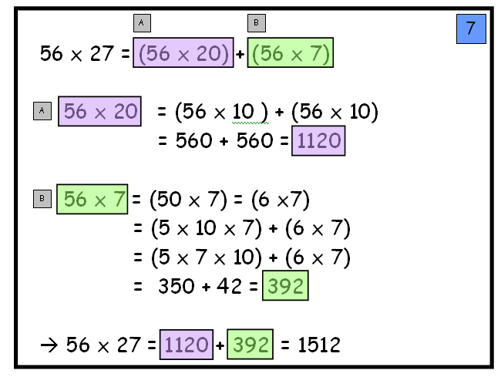
Using similar methods, they will be able to multiply decimals with one decimal place by a single digit number, approximating first. They should know that the decimal points line up under each other.

e.g. 4.9 x 3

Pupils will approximate first
4.9 x 3 is approximately 5 x 3 = 15

x | 4 | 0.9
3 | 12 | 2.7 |  |  | 12
 |  |  |  |  | + 2.7
 |  |  |  |  | 14.7
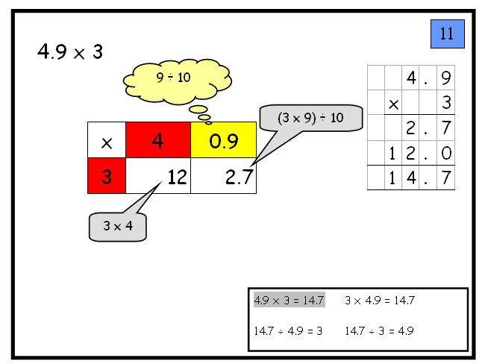

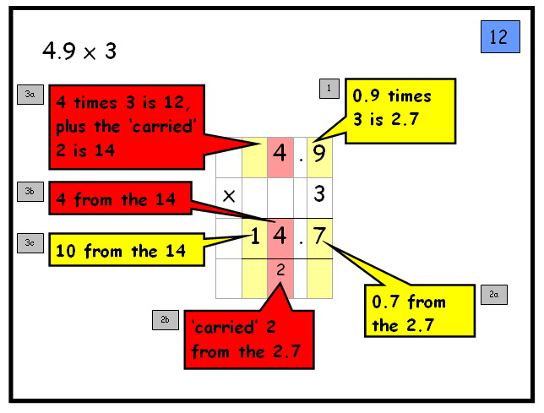

Step 6

ThHTU x U
(Short multiplication – multiplication by a single digit)

4346 x 8

Children will approximate first
4346 x 8 is approximately 4346 x 10 = 43460

x | 4000 | 300 | 40 | 6
8 | 32000 | 2400 | 320 | 48 |  |  | 32000
 |  |  |  |  |  |  | + 2400
 |  |  |  |  |  |  | + 320
 |  |  |  |  |  |  | + 48
 |  |  |  |  |  |  | 34768

HTU x TU
(Long multiplication – multiplication by more than a single digit)

235 x 24

Children will approximate first
235 x 24 is approximately240 x 20 = 4800

x | 200 | 30 | 5
20 | 4000 | 600 | 100 |  |  | 4000
4 | 800 | 120 | 20 |  |  | + 600
 |  |  |  |  |  | + 100
 |  |  |  |  |  | + 800
 |  |  |  |  |  | + 120
 |  |  |  |  |  | + 20
 |  |  |  |  |  | 5640
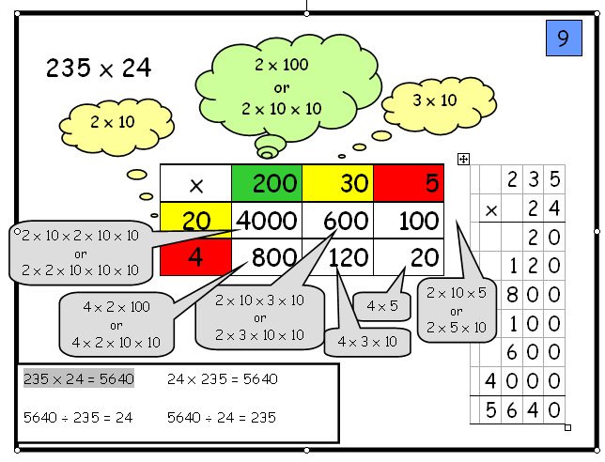
1

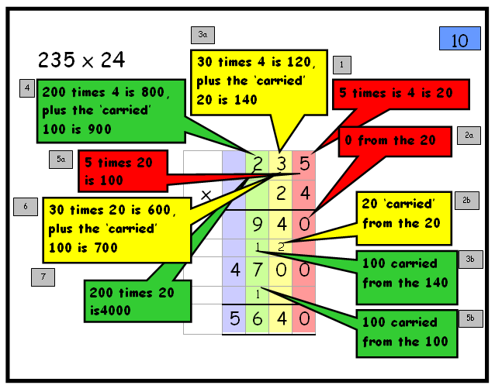

Using similar methods, they will be able to multiply decimals with up to two decimal places by a single digit number and then two digit numbers, approximating first. They should know that the decimal points line up under each other.

For example:

5.82 x 3

Children will approximate first
5.82 x 3 is approximately 6 x 3 = 18

x | 5 | 0.8 | 0.02
3 | 15 | 2.4 | 0.06 |  |  | 15
 |  |  |  |  |  | + 2.4
 |  |  |  |  |  | + 0.06
 |  |  |  |  |  | 17.46
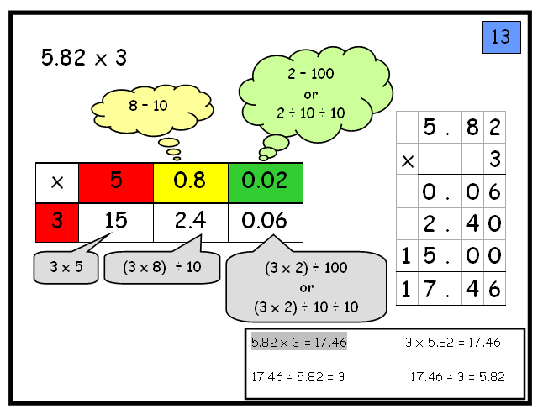

Pupils need to have a range of calculation methods, mental and written. Selection will depend upon the numbers involved

Pupils should not be made to go onto the next stage if:

- they are not ready.
- they are not confident.

Pupils should be encouraged to approximate their answers before calculating.

Pupils should be encouraged to consider if a mental calculation would be appropriate before using written methods.

