INVESTOR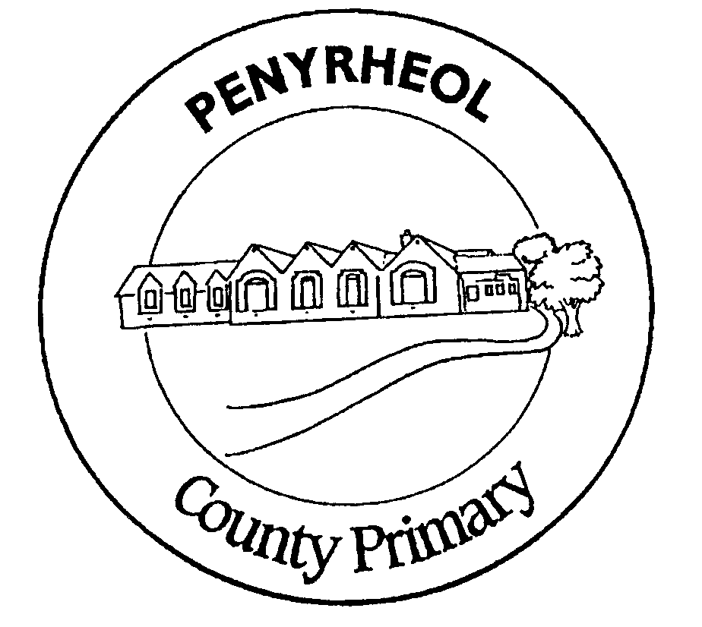

**YSGOL GYNRADD PENYRHEOL**

**PENYRHEOL PRIMARY SCHOOL**

***Putting Children First***

*Plant ynGyntaf*

Art Policy

2018 - 2019

Date of Review: 10th February 2016 Signature: A J Williams

Date of Review: March 2015 Signature: A J Williams

Date of Review: May 2018 Signature: A J Williams

|  |  |  |  |
| --- | --- | --- | --- |
| **Approved by Governors:** |  |  |  |
|  |  |  |  |

*The new National Curriculum in Wales will have 4 Broad Purposes, 6 Areas of Learning and Experience and 3 Cross Curriculum Responsibilities. This Policy indicates how the school is preparing for the new curriculum under the existing statutory National Curriculum Requirements for Wales (September 2014).*

*The United Nations Convention on the Rights of the Child (CRC) is at the heart of our school’s planning, policies, practice and ethos. As a rights-respecting school we not only teach about children’s rights but also model rights and respect in all relationships – Linked to Articles 3, 7, 16 (CRC)*

**SUCCESSFUL FUTURES**

Independent Review of Curriculum and Assessment Arrangements in Wales

Professor Graham Donaldson (February 2015)

The New Curriculum in Wales will be planned to achieve 4 Broad Purposes:

That children and young people develop as:

* Ambitious capable learners
* Enterprising creative contributors
* Ethical informed citizens
* Healthy confident individuals

The Curriculum will be organized into 6 areas of learning and experience:

* Expressive Arts
* Health and well-being
* Humanities
* Languages
* Literacy and communication
* Mathematics and numeracy
* Science and technology

There will be 3 cross curriculum responsibilities:

* Literacy
* Numeracy
* Digital Competence

Full implementation of the New Curriculum in Wales is planned for September 2022. Curriculum planning documents indicate our preparation for the new curriculum as outlined above but remain organized under existing statutory National Curriculum Requirements for Wales (September 2014).

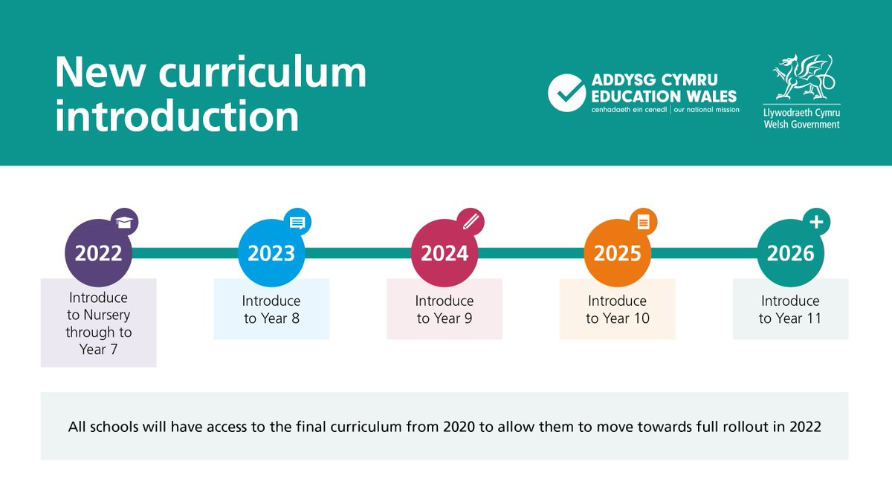

**Purpose of a Scheme of Work**

The scheme of work is designed to ensure a balanced delivery of the art curriculum across the Key Stages and the school as a whole. It also incorporates a degree of progression so that children are continually building upon and developing their skills.

**Implementation**

Teachers should not feel constrained by the scheme of work. It is not designed to limit the children's artistic experiences rather to provide a basic framework. The minimum requirements set out must be met in order to ensure breadth, balance and progression. However, it is also possible for other additional aspects of the art curriculum to be explored within a thematic approach when the opportunity arises.

**Modification of the Scheme of Work**

From time to time it may be necessary to modify the scheme of work in the light of the changing expertise of staff members.

Where teachers have the opportunity to experience new skills by attending courses these skills will be introduced into the scheme of work and the expertise passed on to other members of staff by the "cascading" of information.

**Drawing and Painting**

Drawing and painting should be seen as a continuous and on going part of the teaching of art. Children should be given the opportunity during each year group to explore all the main elements of art:

**Colour** Colour mixing to provide a variety of hues.

Progressing to applying this skill to reproduce colours as accurately as possible. At Key Stage 2 the children should begin to use the vocabulary of art e.g. Vermilion for orange, red and crimson for blue red as well as know how to make them and when to use them.

**Line** Using line to give definition to the outline of an object. Also using lines to give definition to the outline of an object.Also using lines to give a 3D form or texture to an object.Experimenting with different grades of pencil to produce varying effects.

**Tone**  Using shading and shadows to give a 3 dimensional interpretation to drawings.

**Pattern** Looking at the juxtaposition of shapes to produce pattern and decoration. Using the same image repeatedly to form a pattern.

**Texture** Looking at different textured surfaces in observational artwork and using different techniques and media to reproduce this. Using thickened paint and finger paints to produce texture in painting e.g. in work of Van Gogh.

**Shape &**

**Form** In observational artwork looking at the individual shapes which make up the whole object and the proportions of these. Looking at the same object from different angles. Form gives an object its third dimension and depth.

They should be given a variety of experiences of colour mixing, observational drawing by studying artifacts and other artists work and imaginative drawing and painting.During each year children should be given the opportunity to use a wide variety of media in the artwork outlined above and these should include all of the following:

- Pencils

- Pastels

- Crayons

- Charcoal

- Felt Pens

- Powder paint

- and inks at Key Stage 2 only

Progression will be evident in the increasingly sophisticated work produced as the children develop their artistic understanding and skill in using the various media.

The Curriculum is partly based on the Cornerstones of Learning: Engage; Develop; Innovate and Express. The philosophy combines both national and international research and is blended with the best approaches to successful, fun and innovative teaching and learning.Cornerstones form the essential foundation of outstanding teaching and learning and underpin this curriculum.

We use the Cornerstones topics in Penyrheol Primary School. Each project is based on a thematic topic and is organised around the seven areas of learning listed below:

* Personal and Social Well-Being and Cultural Diversity
* Physical Development
* Creative Development
* Language, Literacy and Communication
* Welsh Language Development
* Mathematical Development
* Knowledge and Understanding of the World

How do Creative Beginnings fit with the Cornerstones Curriculum?  Creative Beginnings are intended to provide a springboard for children using the Cornerstones Curriculum. Based on the Four Cornerstones of Teaching and Learning, the projects enable children in the early years to work in a creative and thematic cross-curricular way. By using the Creative Beginnings projects, a school is able to have the same teaching and learning philosophy throughout the early years, the Foundation Stage and Key Stage Two. This not only ensures a smooth transition between phases but consistency in both teaching approaches and expectations.

Skills and learning Art and design in the national curriculum for Wales

**Developing thinking**

Schools should provide opportunities, where appropriate, for learners to develop and apply their thinking across the curriculum through the processes of planning, developing and reflecting. In art and design, learners explore and experiment with a range of information and resources to plan, develop and reflect on their creative activities. They challenge assumptions, look at things in a new way and promote receptiveness to new ideas. They develop the ability to recognise similarities or differences and make unlikely connections, build on ideas to make better ideas, and take advantage of the unexpected. In art and design, opportunities to develop thinking apply throughout the Skills and Range sections of the programmes of study for Key Stages 2

**Developing communication**

Schools should provide opportunities, where appropriate, for learners to develop and apply their communication skills across the curriculum through the skills of oracy, reading, writing and wider communication.

In art and design, learners develop wider communications skills to express their ideas and emotions. They inform their own work by responding to the work of others.

Key Stage 2

Skills

Understanding

Pupils should be given opportunities to:

1. Describe and make comparisons: • between their own work and that of others
2. Evaluate the methods and results of their own work and that of their fellow pupils through: • discussion • reading • writing.

Making

Pupils should be given opportunities to:

Use their experience and knowledge of different materials, tools and techniques: • experimentally • expressively.

**Developing ICT**

Schools should provide opportunities, where appropriate, for learners to develop and apply their ICT skills across the curriculum by finding, developing, creating and presenting information and ideas and by using a wide range of equipment and software.

In art and design, learners apply their ICT skills to investigate, manipulate, develop or realise creative ideas. They select appropriate software and equipment as an aid to designing and making. They regard ICT as a medium in its own right or as part of a multimedia outcome, integrated with other materials and processes.

Key Stage 2

Range

Understanding

Pupils should develop, where appropriate, their understanding through:

• videos

• digital-based resources

• the internet.

Investigating

Pupils should investigate:

• the properties of materials and processes

• natural objects and environments

• made objects and environments

• imagined objects and environments.

They should, where appropriate, apply to their own work findings collected from: • videos • digital-based resources • the internet.

**Developing number**

Schools should provide opportunities, where appropriate, for learners to develop and apply their number skills across the curriculum by using mathematical information, calculating, and interpreting and presenting findings.

In art and design, learners apply number skills such as measurement, estimates, scale, proportion, pattern and shapes to develop, inform and resource their creative activities.

In art and design, there no explicit references to developing number.

**Curriculum Cymreig**

Schools should provide opportunities, where appropriate, for learners aged 7– 14 to develop and apply knowledge and understanding of the cultural, economic, environmental, historical and linguistic characteristics of Wales. In art and design, learners develop at first hand a meaningful understanding of their immediate environment, culture and language. They are given access to historical and contemporary Welsh art and design, enriching their creative activities. They are made aware of how art and design can enhance the environment and how they can contribute to this as individuals.

Key Stage 2

Range

Understanding

Pupils should be stimulated and inspired, where appropriate, by:

• local and Welsh art, craft and design.

Investigating

Pupils should investigate:

• the properties of materials and processes

• natural objects and environments

• made objects and environments

• imagined objects and environments.

They should, where appropriate, apply to their own work findings collected from a variety of contexts including:

• local and Welsh examples.

**Personal and social education**

Schools should provide opportunities, where appropriate, for learners to promote their health and emotional well-being and moral and spiritual development; to become active citizens and promote sustainable development and global citizenship; and to prepare for lifelong learning.

In art and design, learners explore and express their ideas and feelings concerning personal, social, environmental, moral and spiritual issues through their creative activities. Through art and design activities they become aware of other cultures and ways of life, and develop the concept of global citizenship. They enjoy the activities and develop interests that prepare them for lifelong learning, work and leisure.

Key Stage 2

Skills

Understanding

Pupils should be given opportunities to:

Experiment with and examine the methods used by other artists, craftworkers and designers from different:

• periods

• places

• cultures e.g. consider how work from unfamiliar cultures may influence pattern design for their own textile project.

Range

Understanding

Pupils should be stimulated and inspired, where appropriate, by:

• images and artefacts from a variety of historical and contemporary cultures and contexts.

Investigating

Pupils should investigate:

• the properties of materials and processes

• natural objects and environments

• made objects and environments

• imagined objects and environments.

They should, where appropriate, apply to their own work findings collected from a variety of contexts including:

• different cultures and periods.