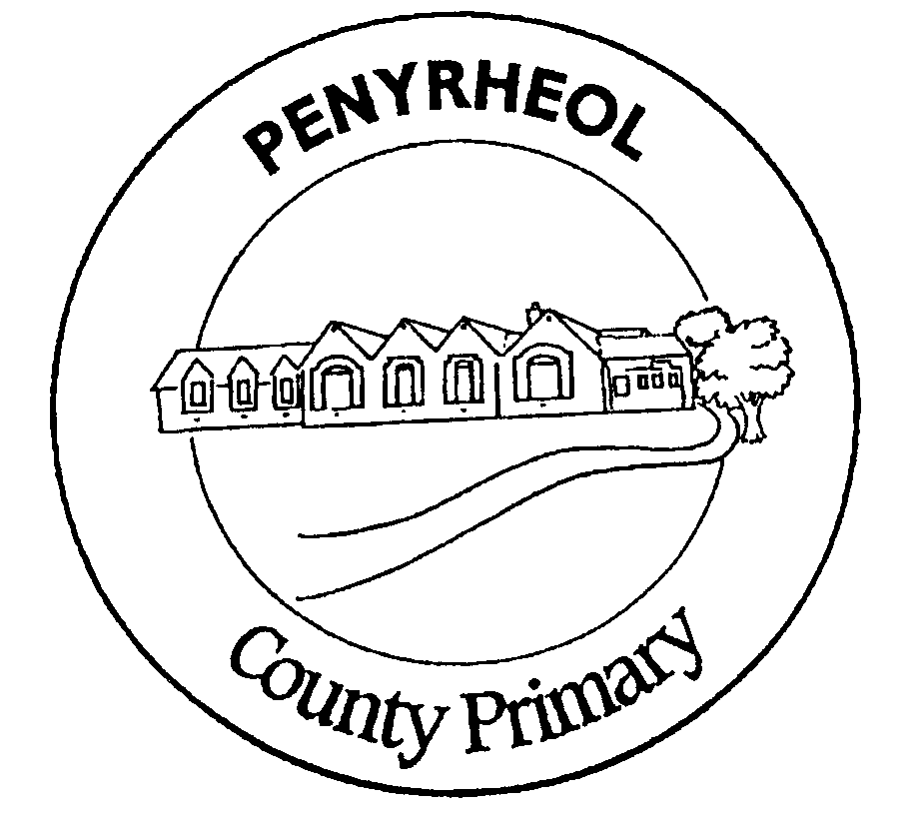
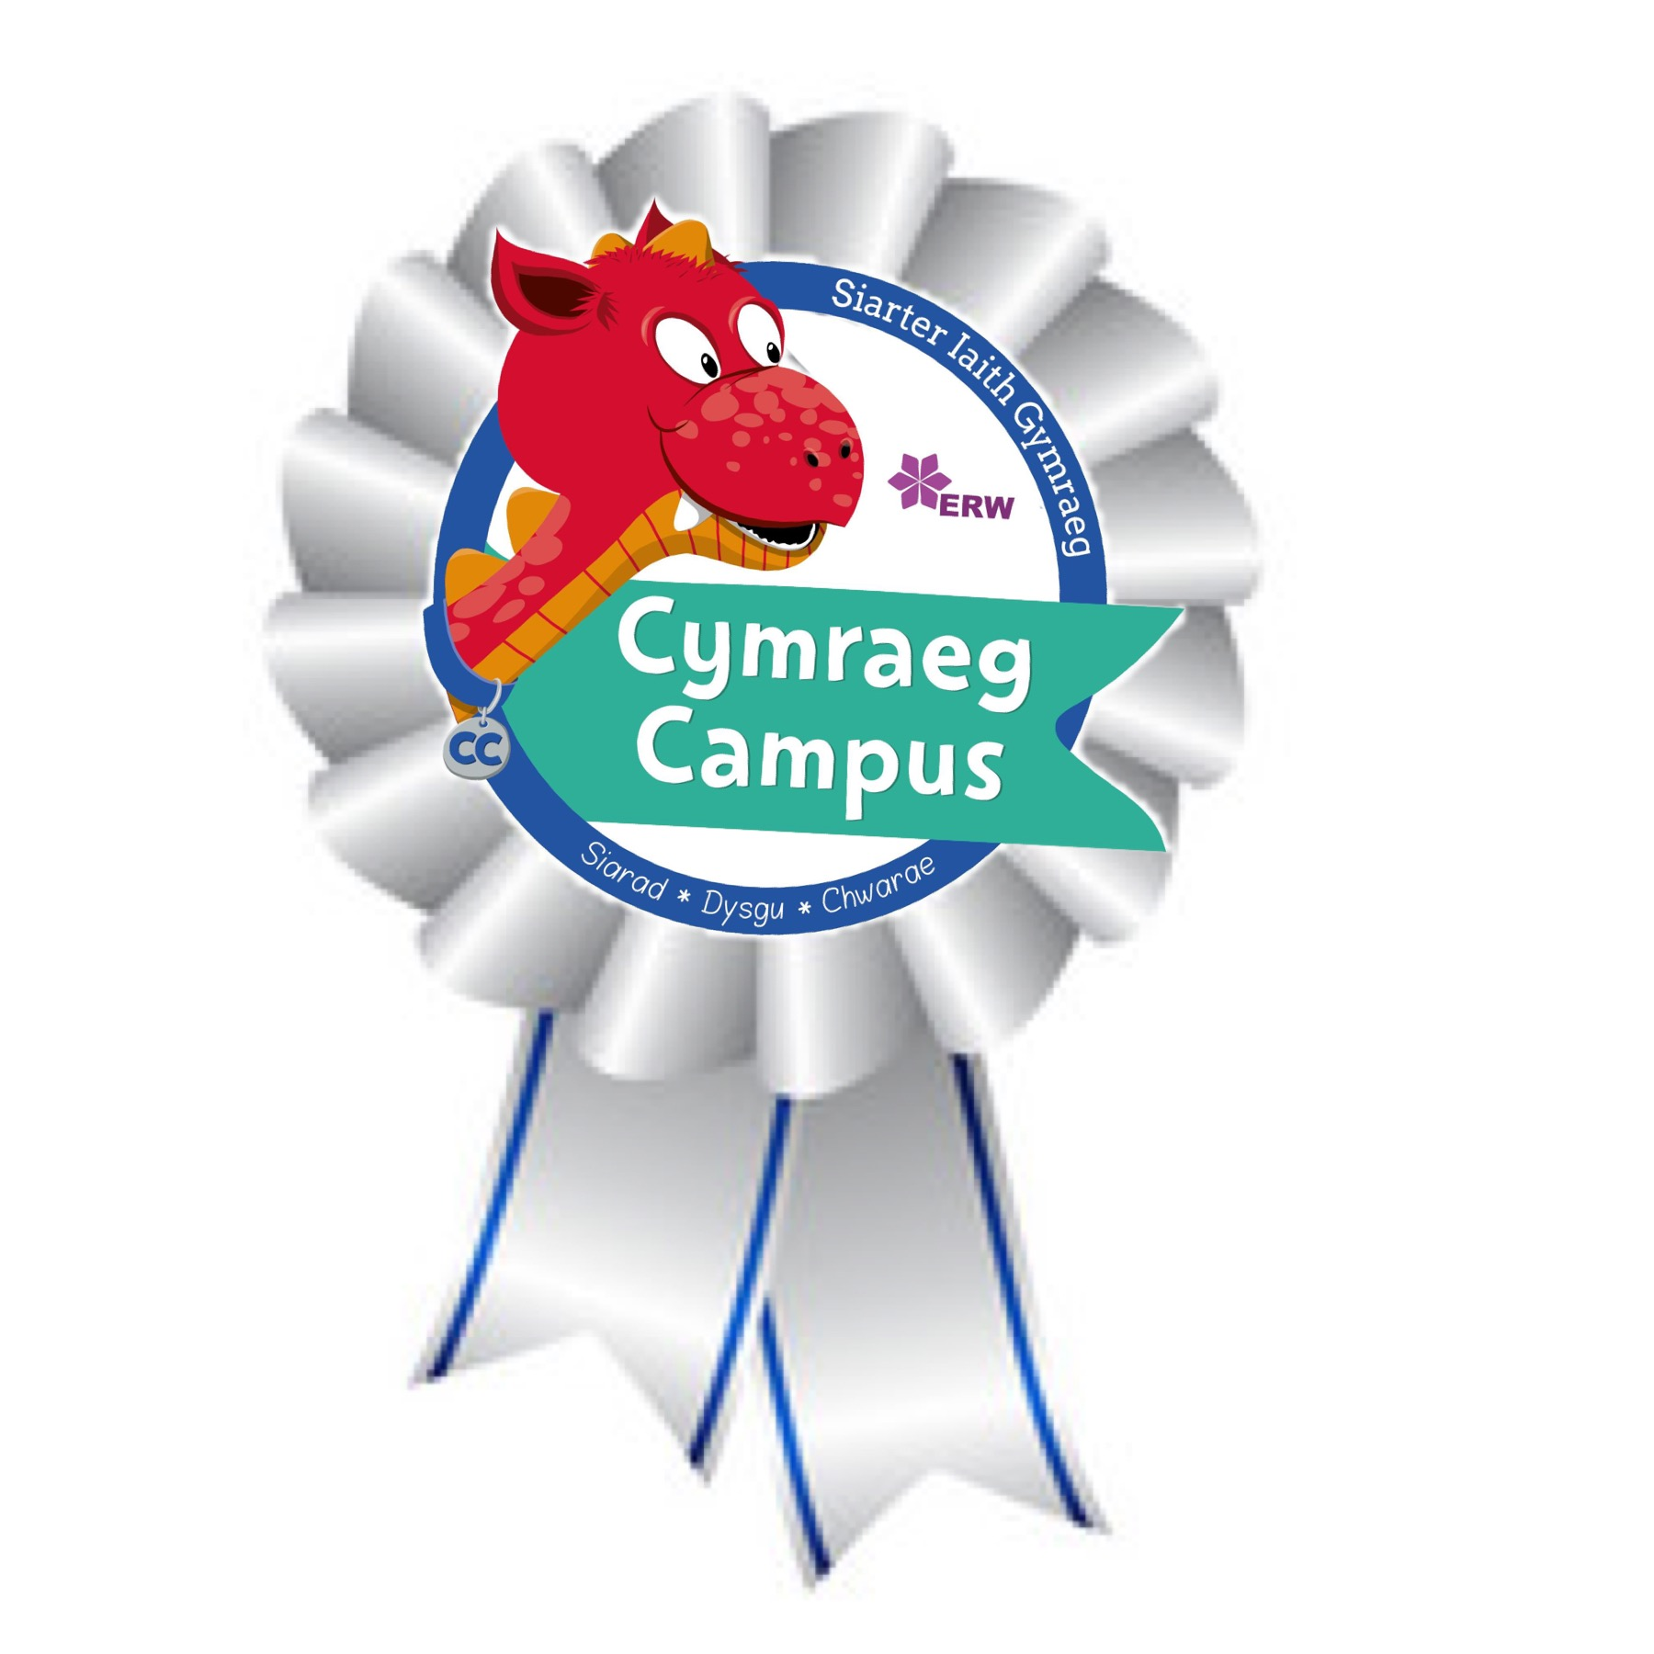
YSGOL GYNRADD PENYRHEOL
PENYRHEOL PRIMARY SCHOOL

Putting Children First
Plant yn Gyntaf

Putting children first to be ambitious and capable learners, ethical and informed citizens, enterprising and creative contributors and healthy, confident individuals.
Assessment, Recording and Reporting Policy
2023 – 2024
The National Curriculum in Wales 2022 is organised around 4 Broad Purposes, 6 Areas of Learning and Experience and 3 Cross Curriculum Responsibilities.
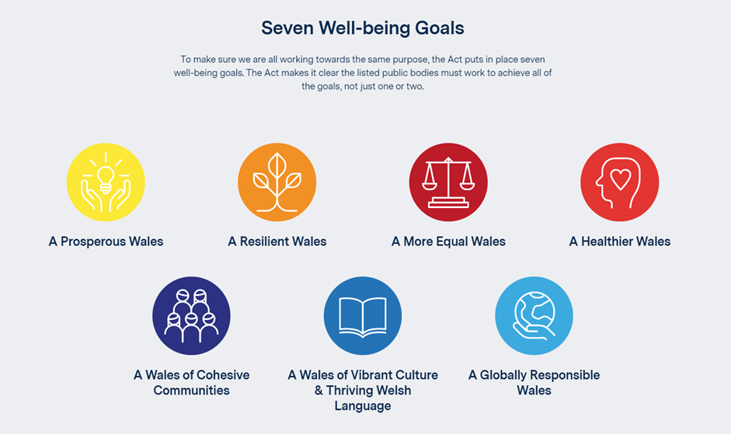
We are fully committed to working towards achieving the seven well-being goals identified in the Welsh Government Wellbeing of Future Generations Act 2015 Health and well-being is central to everything at Penyrheol Primary School.

The United Nations Convention on the Rights of the Child (UNCRC) is at the heart of our school’s planning, policies, practice and ethos. As a rights-respecting school we not only teach about children’s rights but also model rights and respect in all relationships – Linked to Articles 3, 7, 16 (CRC) All learning is also linked to the United Nations Sustainable Development Goals(SDG’s)

Date of Review: 28th June 2023

Curriculum for Penyrheol
Our Vision Ein Golwg ni
At Penyrheol we aim to develop lifelong, enthusiastic, innovative and creative learners who have the knowledge, skills and learning attributes that enable them to deal with whatever challenges lie ahead in a rapidly changing world.

The well-being of our pupils is at the heart of our curriculum and our children learn best through practical 'hands on' learning opportunities; these enable them to experience learning in a meaningful way that reflects their interest and needs. Children are encouraged to follow and explore their own questions and enquiries in a creative environment.

Our curriculum vision is rooted in Welsh values, culture and the Sustainable Development Goals in an authentic context relevant to the child. Children at Penyrheol have a voice and choice in their learning. Children know what they are good at and how to improve. We encourage a growth mindset, which focuses on fostering independence and resilience in an inclusive environment.

It has the development of literacy and numeracy at its core, alongside developing the attributes for children to be good learners, as these are the essential life skills for every child to be able to access future learning. Problem solving and thinking skills are through all areas of our curriculum design .

Rationale

As teachers, we are constantly making judgements about our children’s work. It is this continuous, informal assessment, that enables us to devise tasks that are appropriate and differentiated. These activities can then consolidate or extend pupils’ knowledge, skills and understanding. As such, assessment complements and assists teaching and learning and should be seen as an integral part of the cycle. Assessment should benefit all children equally, irrespective of ability, race, gender and background. This policy outlines the purposes, principles and nature of the management of assessment in our school, and aims to ensure that staff work within an agreed framework, fulfil the same purposes and follow the same principles.

Purposes of Assessment

Assessment should support pupils in their learning. It should:-

- indicate strengths and achievements to be built upon
- provide motivation through success
- support a diagnosis of individual needs
- inform discussions about overall progress with their teachers

Assessment should help teachers’ curriculum provision.

It should:-

- help teachers to monitor breadth and entitlement
- identify areas for development
- measure the effectiveness of teaching methods and resources

Assessment should provide information:-

- for pupils
- for teachers
- for parents
- to assist transfer
- for possible referral
- for audit/inspection

Principles of Assessment

In the on-going assessment of our pupils’ work, the following principles should be borne in mind:-

- Assessment is the responsibility of all staff, with judgements being made across the whole curriculum. This process begins in the Nursery as the teacher observes the child’s social development at play.

- Assessment will be on going and assessment opportunities should be planned for as part of our curriculum planning.

- Information gathered from assessment activities should be used to plan further work to meet individual learning needs.

- Assessment can confirm the teacher’s judgement that achievements demonstrated by pupils on a particular occasion can be reproduced at different times and in different contexts.

- As in our class lessons, success criteria must be clear for both teachers and pupils.

- Assessment should reflect the range of teaching and learning activities and relate to specific criteria (WILF)

- Assessment should allow the children to develop as much responsibility as possible for their own learning and self assessment.

- Assessment should be supported by a variety of evidence.

- Data gained from the assessment process should be taken into account when pupils move from class to class. In this way, we can sustain the coherence and continuity in our pupils’ learning.

Nature of Assessment

Assessment should not dictate the nature of the curriculum, but should be an integral part of the teaching and learning process. The main type of assessment will be formative, where we are gathering information to help plan the child’s next steps. Diagnostic tests can be used when we need to pinpoint where a particular weakness lies. Standardised tests (National Reading, Numeracy Procedure and Numeracy Reasoning Y2-Y6) will provide a summative assessment, ie, a snapshot in time of a child’s achievement. As well as the National Tests pupils will complete a reading assessment termly (Y3 – Y6). On entry into school pupils will be assessed against the Foundation Phase Profile, which will provide a baseline. Pupils will be reassessed on entry into a new school year until Y2.

Assessment may take many forms. We will need to plan a range of activities appropriate to the ability levels within the class. Within these activities there will be differentiated assessment opportunities to ensure all children have access to the tasks, eg, some will be assessed orally, while others may produce detailed written work.

Our assessment practice will focus on the following strategies:-

- Numeracy pathways and Rubric milestones in Literacy.
- Hot write / cold write (Literacy)
- Over to you / prove it (Numeracy)
- Classroom questioning
- Sharing success criteria with learners (WALT and WILF) and AFL strategies
- 2 stars and a wish / exit slips
- Traffic Lights/Smiley Faces
- Pupil feedback/show me on whiteboards/popcorn answers/ P4C
- Marking/self assessment
- Feedback to and by students and initial teachers marking comment/ purple pen of progress
- Testing/Assessment data
- Observation/Performance

i) Classroom Questioning

Questioning strategies are vital if we are to check pupil understanding, even when a child gives an incorrect answer. Questions should not only reward simple recall of information but, more importantly, assess the thought processes the child has used in order to respond through higher order questioning.

We must allow processing time, especially with younger learners. Children have the opportunity for paired discussion, ensures everyone has an answer and avoids thoughtless responses. The following example questions are intended to check understanding rather than reward simple recall of information.

- Can you sum up what’s been said?

- How do you know? Can you tell me why?

- If you were to teach this to your younger brother, how…?

- What would be a good question to ask a Roman Centurion? Try your question on someone nearby. They have to answer as a Roman Centurion would.

- What other alternatives did you consider?

- Can you convince the others why you are right about your answer?

- Prove it

Understanding may be further consolidated through reflecting back to the pupil, ie, “So, if I’m right, what you are saying is…..”

- Sharing Criteria with Learners (WILF)

In order to improve their work our pupils need to understand “what counts as quality.” The implementation of pathways and Rubric milestones enhances the effective dissemination of what constitutes a good piece of work at a particular level. Children and staff are all clearly aware of the next steps for learning and are able to demonstrate pupil progress appropriate to their ability and stage of develop within any given task.

- What will the finished piece of work be like?
- What does a good one look like?

- How will you know you have successfully completed it?

Answering these questions through discussion, should give the children a clear picture of what they are expected to produce.

This process can be further enhanced through shared sessions based on the work of previous classes, eg, using a story written by a pupil from a previous class the question can be asked:-

In pairs, can you discuss and agree what is good about this story?

In this way, our children can become more confident about the criteria they have to respond to.

iii) Marking/Feedback/Self-Assessment

Effective marking and feedback will result in the child thinking about how his/her work could be improved. In order to move the child along the continuum of learning, he/she must understand clearly what the next step is in improvement. Feedback should therefore be on a constructive comment only basis about the particular qualities of a piece of work with advice on what to do to improve. Such formative assessment should indicate the direction of future learning. Our comments will therefore include a celebratory comment in welsh and an indication of the next step, beginning with an imperative verb.

Formative assessment is based on progress against agreed criteria and not comparison with other pupils. In order to move our children on, we need to tell them how their present work compares with previous similar tasks. In this way, even less able pupils may experience the motivation of self-improvement.

Through understanding the standards used for assessment, our pupils will develop further their self-assessment skills. These skills can be enhanced through increasing the onus on the learner to find mistakes and self correct through our marking feedback, which includes a think bubble.
Teachers will respond to work with a positive comment in welsh, followed by an imperative verb challenging the children to further develop their learning.

Examples

- In written work, the correction of spelling could develop as follows:-

- Key words / high frequency words are picked out and corrected, with the teacher using a symbol (two eyes) within KS2 to show the words which need to be corrected and learnt. A maximum of 5 words should be highlighted. Pupils then find the misspelt word and correct the spelling and write it again once.

- In their marking, teachers will encourage a learner to use a thesaurus/dictionary to find a more interesting alternative.

iv) Feedback by Pupils

Feedback by pupils during the lesson and as part of the interim plenary sessions throughout the lesson, provides an opportunity to check pupil understanding, as they attempt to sum up/explain what has been learned.

v) Assessments

This may be oral assessment or written testing.

Oral Assessment

- Presentations
- Group Discussion
- Role Play
- Problem Solving
- P4C

Written Assessments

- National reading, numeracy, procedure and reasoning assessment
- Group reading tests
- No more marking writing assessment
- ALN specific assessments

Planning for Assessment

Whatever type of assessment used, the opportunities for assessment will need to be carefully thought out at the planning stage of the current topic

Assessment For Learning (AFL)

The aims of Assessment for learning for Penyrheol Primary are:

- To build a more open relationship between pupil and teacher where pupils are confident to take risks for learning and teachers provide very clear expectations and positive feedback to move the learning on.

- To involve pupils in the learning intention for every lesson.

- To enable pupils and teacher to take an active role in identify success criteria.

- To give pupils the opportunity for self evaluation and peer evaluation

- To promote pupil’s active listening and questioning skills.

- To celebrate success-recognition of every pupil’s achievement.

Practices:

The aims of Assessment for learning will be achieved through the following practices:

- Effective Planning-using a thematic approach to planning teachers to ensure that learning experiences are differentiated; meaningful and stimulating. Self evaluation by both teachers and pupils will be built into the planning. Planning has been reviewed to address agreed multi-agency “Reducing Workload” guidance 2017.

- Sharing Learning Intentions-use of “We are learning to” (WALT) at the beginning of every lesson. Focus the learning intention on transferable skills

- Shared Success Criteria-a verbally agreed success criteria which will help identify the steps needed to complete a task. The use of modelling and shared activities to make explicit the success criteria

- Effective Questioning-using more open ended questions, giving more thinking time (no hands up), using pair share to help pupils feel more confident to put forward new ideas, think out loud, explain their reasons and explore their understanding.

- Feedback-this is essential for effective learning and teaching. Strategies such as comment only marking or providing prompts for improvement can help plan the next steps in learning. Children have the opportunity to respond to and initial all teachers comments within KS2.

- Self Assessment-allowing pupils time to reflect on what they have learned and how they have learned it during plenary sessions, to make explicit the links between what they have learned and the success criteria. This will be done through strategies such as traffic lights, exit slips and other useful thinking prompts.

Reporting to Parents
Pupils’ progress will be reported to parents annually through a written report. Parents will have the opportunity to discuss the written report.

Parents will have the opportunity to discuss their child’s progress during the Autumn and Spring term.

Monitoring

Monitoring to take place in a variety of ways. A particular strength is the mutual respect and collaborative culture that has been developed. Staff are required to bring examples of maths books, English books, learning journeys and reading records for discussion at regular staff meetings. Teachers will be asked to provide feedback on how Assessment for learning techniques and strategies are being implemented. This will be done through learning walks and presentations to Governors.



