



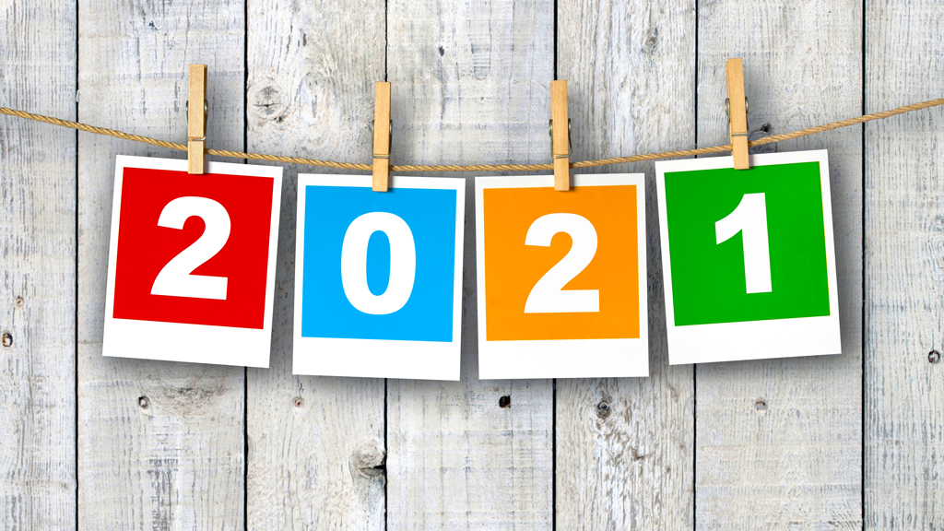

Write 2021 in words

What is the value of the underlined 2 in 2021?

What is the value of the 1 in 2021?

What is the total of the individual digits in 2021?