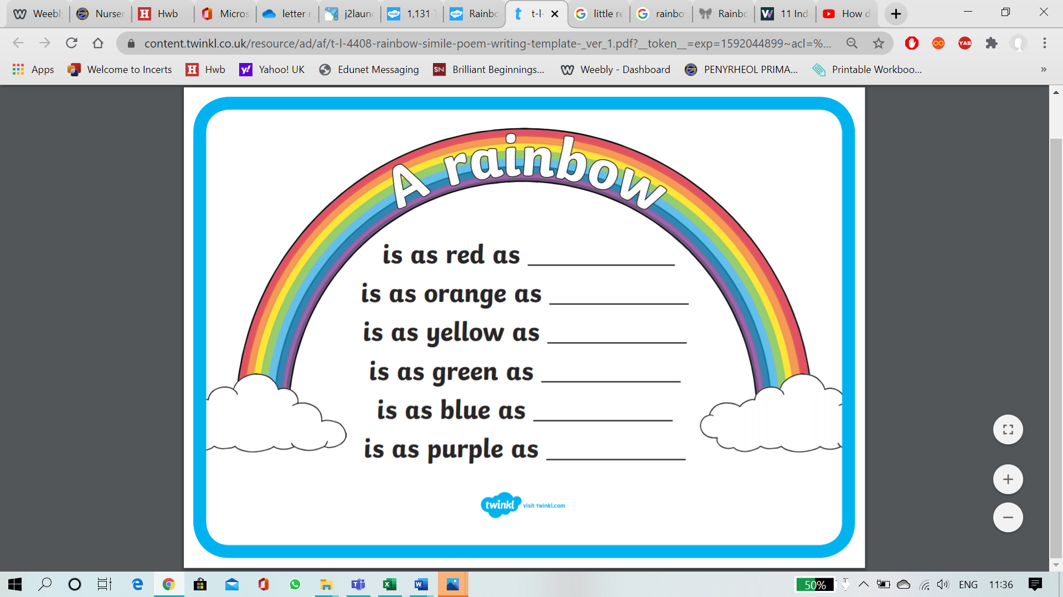

**Can you think of a coloured object to match each welsh colour of the rainbow?**

**glas**

**Coch**

**porffor**

**Oren**

**Melyn**

**gwyrdd**