Activity 10

Get writing

Now decide on what happens in your wishing story

In my story, the wish arrived in the form of a lucky scratch card or golden ticket. Here are some objects that have been used in stories before:
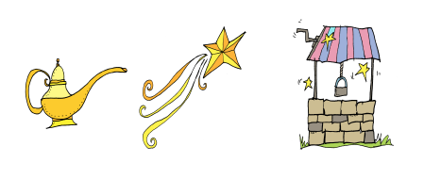

What other objects could be used?

Some ideas

You might want to pick an interesting object you could use in your story and then think about how this might arrive and how this could link to a setting and different characters. Try to have two characters who are different. One could be cautious and ignore the warning, the other will not, causing something else to happen that they did not expect – be careful what you wish for! Think about the mood or atmosphere. How might you make the weather reflect the bad news that is coming?

If you want some help, try reading some other wishing tales:

Sausage Nose, a Swedish Folktale retold by Dianne de Las Casas 2008
https://professionalstoryteller.ning.com/m/group/discussion?id=1984817%3ATopic%3A18302

The Golden Touch
http://classictales.educ.cam.ac.uk/stories/metamorphoses/kingmidas/Midas_Part_1_transcript.pdf

Now plan your own wishing story

Here is the underlying pattern of the story to help you plan a new version. Jot
down some ideas in note form before starting so that you know where your story is going. You can always alter the plan a bit to fit your story and remember, you can always change your mind as you write.

Underlying story pattern | Plan for your story
Main character in a safe, homely setting: one dreaming of a fortune or change.
An object arrives with a :too good to be true” promise or wish

One character warns against, but the other character ignores the warning and makes a wish.
Nothing happens. Yet!
Wish comes true but with unforeseen consequences.

Character wants to use another wish to put things right, but the object has disappeared.

