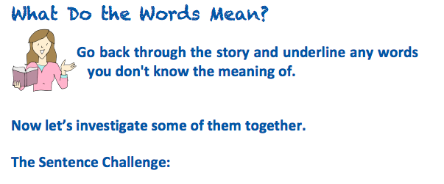

Sentence from text | Focus word | Dictionary definition
…..rain streaked the classroom windowpanes | streaked | To move rapidly

Now write a sentence of your own using the word streaked

For example
John streaked along the pavement towards the crowd.

Sentence from text | Focus word | Dictionary definition
….. a resurgence of the game slap | resurgence | Something that starts again after disappearing for a while

Now write a sentence of your own using the word resurgence

For example
The teachers have seen a resurgence of skipping games in the playground

Sentence from text | Focus word | Dictionary definition
….. the ferocity of a wild beast | ferocity | Extremely fierce (strong, powerful, violent or frightening)

Now write a sentence of your own using the word ferocity

For example
We were surprised at the ferocity of the storm

