Activity 2

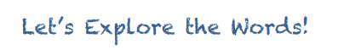
We’re going to investigate some of the words from the text.

Use dictionary (it can be an online dictionary) to find the meanings of the words and tick which picture shows what each word means

