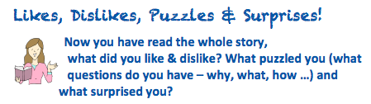

I liked ……



I disliked ……



I would like to know ……

I was surprised at ……

