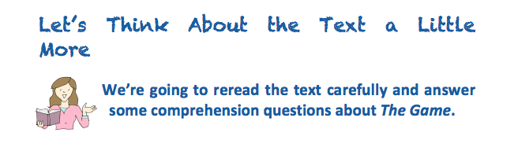

- Does The Game remind you of any stories you know? List them below

- Danny and Susie had a good choice of things to do at wet playtime. If this true or false? Explain how you know.

- Find and copy a word that is close in meaning to disappointment.

- Write down two things the children are doing in the classroom.

- Is Mrs Allbright the teacher in the classroom? Explain how you know.

- Why might another wet play time be stressing Mrs Allbright?

- Look at this comment from Danny
“An animal game. Boring!” said Danny, already losing interest.
Why might Danny think the game was boring?

- What were three signs that something bad was going to happen once the game started?

- List the things the spider did once it was out of the game

- The text says: “Her eyes widened in horror as she realised what was coming next.” What might Mrs Allbright be thinking at this point?

- Why did Susie put the dice and counters into the bin?

- Billy spotted the game on the shelf at the end of the story. What do you predict might happen the next time it’s wet play?

