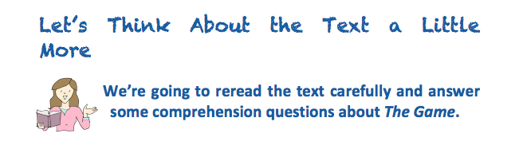

- Does The Game remind you of any stories you know? List them below

- Danny and Susie had a good choice of things to do at wet playtime. Is this true or false?
- Which of these words is close in meaning to disappointment.
Dismay resurgence unusual

- What was the only game that was left?

- Who is Mrs Allbright?

- What was Mrs Albright doing?

- Name two animals that were used as counters.

- Who went first in the game.

- List three things that happened once Susie landed on the spider

- What kind of spider is mentioned in the story?

