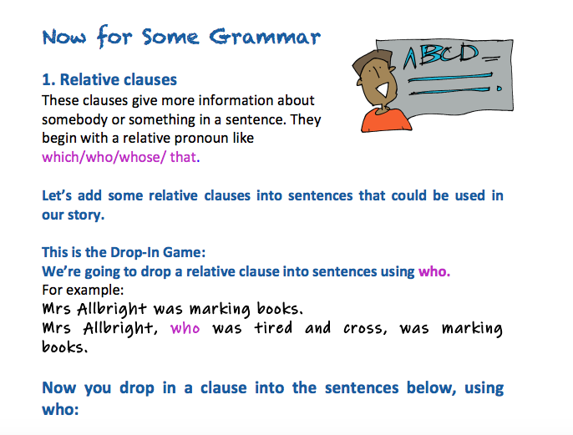

Danny was looking out of the window.

Susie ran to the door with the box.

Freya watched The Voice on the iPad.

Now have a go at dropping a relative clause into the sentences below using which.
For example: The desks were covered in board games.
The desks, which were bright blue, were covered in board games.

The board game intrigued Susie.

The netball court looked slippery.

The dominoes were in the basket.

