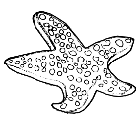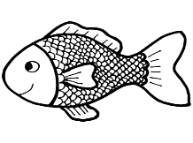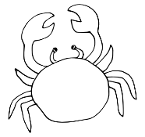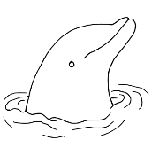

**Enw: Dyddiad: ___________________**

**Chwilair Lan y Môr**

**môr haul pysgodyn**

**tywod bwced octopws**

**rhaw cranc seren fôr**

**pêl siarc dolffin**

|  |  |  |  |  |  |  |  |  |  |
| --- | --- | --- | --- | --- | --- | --- | --- | --- | --- |
| **p** | **y** | **s** | **g** | **o** | **d** | **y** | **n** | **s** | **s** |
| **p** | **ê** | **d** | **c** | **b** | **i** | **h** | **l** | **e** | **i** |
| **o** | **c** | **o** | **t** | **w** | **ê** | **a** | **h** | **r** | **a** |
| **rh** | **ô** | **l** | **a** | **c** | **s** | **u** | **g** | **e** | **r** |
| **a** | **f** | **ff** | **d** | **e** | **a** | **l** | **r** | **n** | **c** |
| **w** | **c** | **i** | **w** | **d** | **l** | **f** | **n** | **f** | **d** |
| **b** | **n** | **n** | **t** | **y** | **w** | **o** | **d** | **ô** | **m** |
| **rh** | **c** | **o** | **c** | **t** | **a** | **l** | **h** | **r** | **ô** |
| **a** | **o** | **c** | **t** | **o** | **p** | **w** | **s** | **ô** | **r** |
| **p** | **ê** | **l** | **e** | **c** | **r** | **a** | **n** | **c** | **ff** |