Activity 4

Now read or listen to the story

You can listen to it here:
https://soundcloud.com/talkforwriting/one-chance/s-A3SQppItbOx

One Chance

Outside, the evening was cold and wet. A squally wind howled, rattling the roof tiles and shaking the window frames of 13 Wager Road. Inside, shabby curtains were drawn, a humble fire crackled and a couple sat in silence. Jack stretched out on the tired couch with an amused smile, turning the page of his favourite novel. Sarah scowled, silently seething. She scanned the room, noticing the worn-out furniture, peeling paint and, in her opinion, a pointless, idle husband. She deserved so much more than this.

Suddenly, the letterbox jangled and there was a solitary but decisive knock on the door. Hope, the Labrador, barked. Sarah pulled back the curtain and watched as a hooded figure slipped silently away up the road. Puzzled, she stared down at a golden card that had appeared, glinting on the frayed
doormat.

Tentatively, she gathered it up and read it out loud:

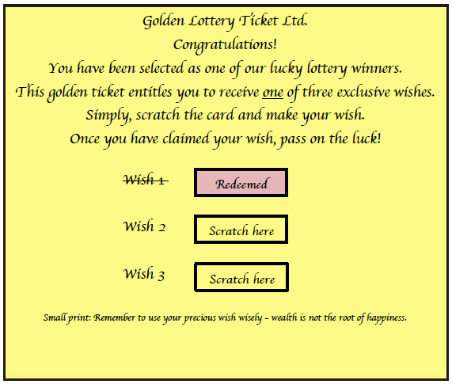

think happens next?
What next? We’ve stopped at an interesting part of the story. What do you

I predict ….

Now let’s find out how close your predictions were. Read on!

Sarah gasped. This is just what she was looking for – another chance. Maybe lose
the idle husband as well, she thought, shaking her head.

“I am going to give this a go. I am thinking lots of money to buy expensive clothes
and maybe you can finally sort this house out,” she said to Jack, rummaging
desperately in the drawer for a coin.

“Utter nonsense,” muttered Jack, glancing up from his book and taking in the room.
“I love this old house and you just the way you are. Even if all that did come true,
there’ll be a catch. No one gets something for nothing. Just throw it away.”

Sarah stopped and nodded sullenly. He was right. She made to throw the ticket on
the fire, but something stopped her. Furtively, she stashed it in her pocket.

Later that evening, as Jack slept, Sarah retrieved the ticket and greedily scratched
‘Wish 2’, dreaming of immense riches or, to be precise, £100,000. Outside, a squally
wind howled. Inside, nothing happened. Bitterly, she tossed the ticket into the bin.

The next day, the wind died down to a cool, whispering breeze. Jack prepared for
his early morning walk with Hope. Pulling his woollen hat firmly down over his ears,
he called out to Sarah that he wouldn’t be out long and left. Sarah scowled. She
could barely respond.

Eight hours passed and Sarah began to worry – where were Jack and Hope? Shaking
with fear, she dialled 999, hoping for the best but fearing the worst.

A massive search was launched but there was no sign. Jack and Hope had simply
vanished. Sarah was distraught. Deep down she worried if their disappearance had
anything to do the golden ticket.

Days later, as the wind whipped up again, a woman in a black cloak knocked at the
door. She told Sarah she had been sent to offer some compensation for her sad
loss. Sarah was feeling desperate so asked, “How much?”

“Shall we say… £100,000?”
Shocked, Sarah recalled the greedy sum she had wished for. Could it be true? Had
her selfish wish actually been granted? Quickly, she raced outside and rummaged
desperately through the bin, trying to locate the discarded ticket. With sickening
dread, she smoothed out the crumpled ticket and gasped in horror. It was true. The
second wish had been redeemed.

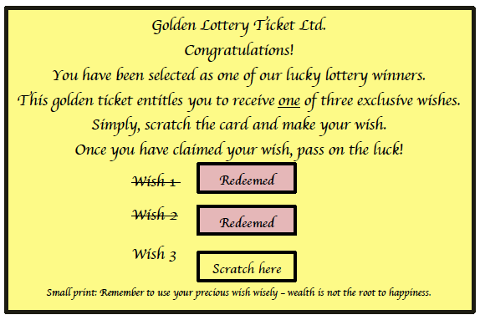

Sarah leaned against the bin for support, her head spinning, her thoughts in turmoil.
Then she gathered herself together. There was still one final wish left … Could she
use it to try and bring Jack and Hope back? She needed a coin, quick.
Just then, without warning, the squally wind howled and snatched the ticket from
her hand. It spiralled, higher and higher like autumn leaves in a storm and then, like
the mysterious woman herself, it was gone. Sarah cried out of helpless pain.

Inside, the shabby curtains were drawn and a humble fire crackled.

