Activity 5 Part 2

Similar meaning or opposite meaning

Now investigate words that are similar (synonyms) or opposite (antonyms or near antonyms).

Target Word | Synonym | Antonym or near antonym
squally | stormy, windy, tempestuous, blowy, blustery, breezy | Calm, pleasant, serene, tranquil, motionless, undisturbed
shabby
humble
scowled
rummaged
stashed
distraught
discarded
turmoil

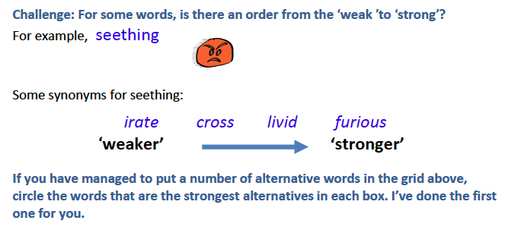
Now choose some of the words you like and try and make a sentence using the word.

For example, seething

Sarah’s seething resentment finally reached boiling point.

At the end of the match, the seething mass spilt out of the football ground.

