Activity 6

Likes, dislikes, puzzles and surprises

Now you have read the whole story, what did you like and dislike?

I liked ……

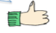

I disliked ……

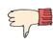

I would like to know ……
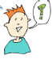

The story reminded me of……
