Activity 8

Creating a mood with a sentence of 3

In the story, I’ve tried to create an atmosphere or mood by writing a brief description of the setting, using prepositions “outside” and “inside” to start the sentences to contrast the moods and using sentences of 3 to build the description. If you look at the “outside” sentence below carefully, you’ll see that it tells us 3 things that the wind is doing.

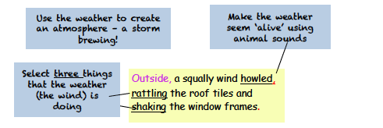

Have a go at writing your versions of this sentence to create an atmosphere by telling your reader 3 things the weather is doing. And remember the commas!

Outside, …..

Outside, …….

Outside, ………

Now add a second sentence of three. Look at the “inside” sentence below and you’ll see that it gives us three details about the inside of the house

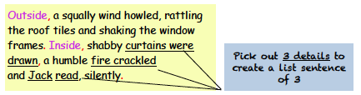

Have a go at writing your own versions of this ‘inside’ sentence by picking out 3
details. Here I chose curtains, a fire and Jack. Then I added some descriptive
detail. Look about you and pick out three things to describe like the TV, a mug
and the dog.

Inside, the TV was muted, a chipped mug of coffee steamed on a small pine table and a white dog slept, whimpering.

Inside, …..

Inside, …….

Inside, ………

