Activity 9

Writing speech

In a bit, you will be writing your own story. Start thinking of two
characters who will be in your story.

You might want to create a character who was always wishing that he or she didn’t have to go to school and is now regretting their wish! The other character warns them against this.

In stories, one character often speaks and another replies. This helps move the
story along and should tell the reader something about the characters. We need to make sure we lay out the speech clearly and punctuate the way that they speak so that the reader knows:
• what’s said • who said it • how they said it.

There are some golden rules for writing speech:
1) Put inverted commas (“ ”) around what is actually said.
2) Begin a new line (paragraph) for every new speaker.
3) Always begin a new piece of speech with a capital letter.
4) Always put some punctuation at the end of the speech – . , ! or ?
5) To make it interesting, tell us how the words were spoken.

Have a look at my cartoon example:

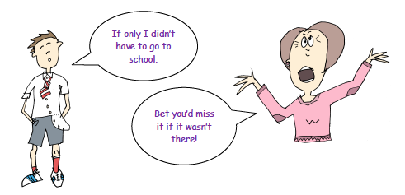
With cartoons, you want the words spoken to interest the reader and move the story along and you use the images to help them picture what the speaker is like, how they feel etc. Writing speech in a story is very similar except this time you have to use words to paint the picture of how the speaker is feeling and how they react to what someone else has said. Look at the example below:
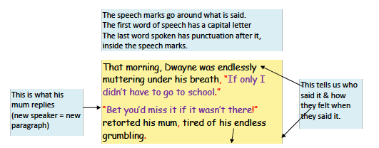

Now it’s your turn. Decide on your two characters. Make character 1
wish something and character 2 react. Let the reader know how each
character feels. Write what they say into the speech bubbles and draw
an image to show us how each speaker feels.

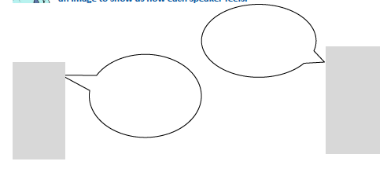
Now turn your cartoon into a short dialogue from a wishing story. Use the
pattern and punctuation that I used on the previous page to help you. Use the
words you select help the reader picture the scene.

