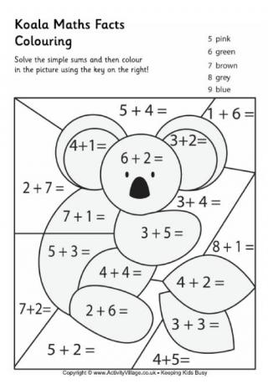

Answer key:

5=pink 6=green 7=brown 8=grey 9=blue

**Addition Koala**

Solve the addition problems below and colour using the key provided