Dragon
Dangerous dragon
Raw meat eater
A scary beast
Gigantic wonderful wings
Odd horns
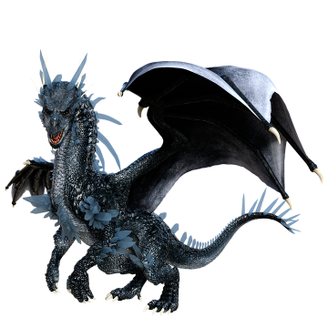
Nasty smelly breath
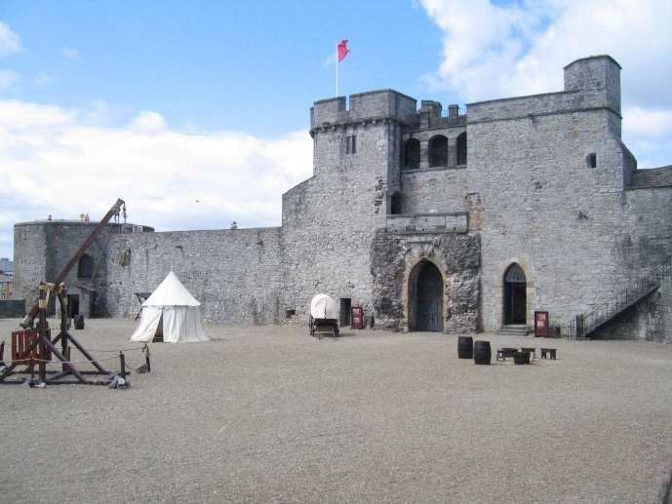
#

Castle
Courtyards and chapels
Arrow gaps in the wall
Stable tower used for lookout
Teeth of the portcullis are sharp
Listening for enemies
Enemies will NOT get in!

