Amphibian Fact File

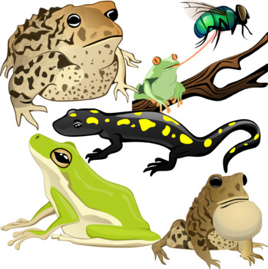

Choose an amphibian to research and present a fact file on your chosen amphibian.

- Include a title
- Include key facts
- Include diagrams / photos / drawings
- Include subheadings to organise your work
- Organise information in fact boxes
- Include technical words
- Include a glossary

