At that moment, the table began to shake, then the windows rattled and the floor vibrated. Everyone stopped what they were doing and the room fell silent.

“EARTHQUAKE!” shouted Billy, bursting into laughter. He soon stopped, as in a blink of an eye, an enormous spider, bigger than a horse, shot out of the game and landed in the centre of the crowded classroom. Everyone froze. Its enormous, hairy legs were tensed, ready to pounce and its whole body seemed to pulse. Eight bulging eyes scanned the room and then…

It sprung into action. It crushed the tables, smashed the windows and flung children all around the classroom with a flick of its legs. It powered towards Mrs Allbright as she stood rooted to the floor in terror. The room was filled with shrieks of panic and despair.

“What shall we do?” shouted Danny desperately, pressing himself tightly against the wall.

“Read the instructions,” ordered Sally, “We have to stop it!”

What other problems could the game cause? What else could come out of the game and what would it do?

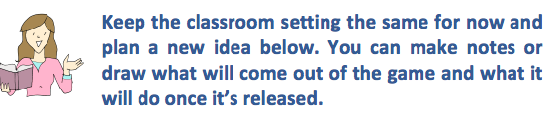

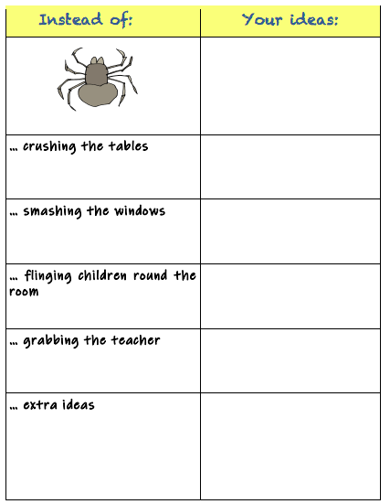

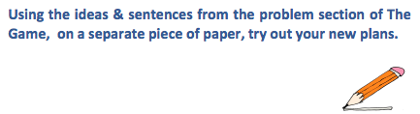

Follow this pattern:

Start with the first strange events as a sentence of three and then show how the children react:

At that moment, the table began to shake, the windows rattled and the
floor vibrated. Everyone stopped what they were doing and the room fell
silent.

At that moment, …

Next, introduce the new threat. Tell us where it came from and what it looked like:

In a blink of an eye, an enormous spider, as big as a horse, shot out of the
game and landed in the centre of the crowded classroom. Everyone froze.
Its enormous, hairy legs were tensed, ready to pounce and its whole body
seemed to pulse. Eight bulging eyes scanned the room and then …

In the blink of an eye, …

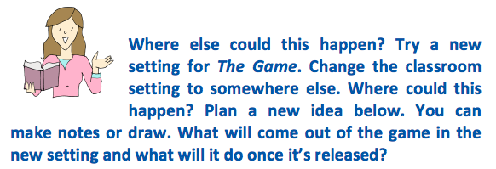

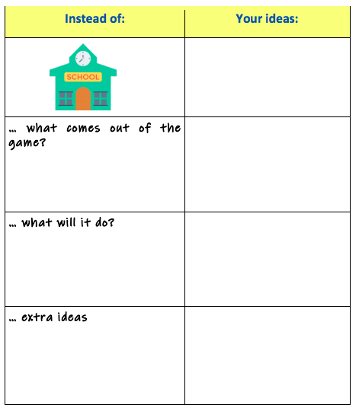

Now write your new problem, set somewhere else: start with the first strange event, then introduce the new threat and finally describe what the threat does. Do this on a separate piece of paper.

