Beth wyt ti’n feddwl? What do you think?
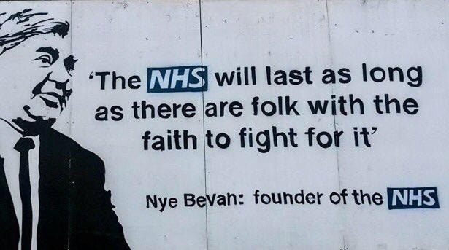 | Find out what these words mean…  faith  folk  NHS  What do you think this quote means?
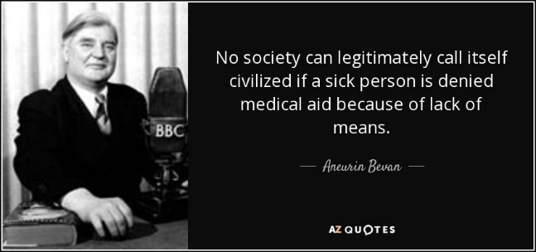 | Find out what these words mean…  Society  Legitimate  Civilized  Lack of means  What do you think this quote means?

