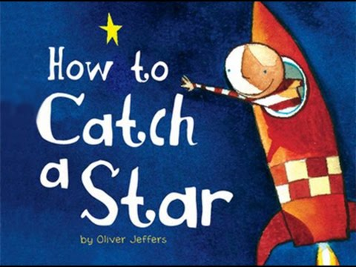
Can I organise the story?
After listening and talking about the story
complete this activity sheet

List the characters | List the settings (where the story took place)
What was the problem? | How was the problem solved?

