West Glamorgan Regional Partnership Board
c/o West Glamorgan Transformation Programme Office
Civic Centre
Oystermouth Road
Swansea
SA1 3SN

Providing care and support to the most vulnerable people in our communities is a significant responsibility placed on our councils – a responsibility that we take very seriously.

The national emergency situation, created by the spread of the Coronavirus, has already increased pressure on our social services departments and the wider care sector. In the weeks ahead, the projections from Welsh and UK Governments indicate that we need to plan to provide care and support for very many more people with fewer staff able to work. Evidence from other countries indicates that in order to cope with this expected surge in the need for care and support, we need to change the way in which care and support is provided – changes that are unprecedented and unlike anything we have experienced in our lifetimes.

It is important you know that our Directors of Social Services and their teams have already taken a number of steps to increase the numbers of staff available in the social care workforce and that they have also expanded the number of residential care places available across the region. However, even this expanded capacity is not going to be enough to respond to the expected surge in the coming months as the Coronavirus peaks.

Therefore, we will need to further prioritise those who will be able to receive care and support from social services, create even more capacity in our social care system while also making alternative arrangements for those who will no longer be able to have their needs met by social services. Families and communities will have a particularly important role to play in this.

We are committed to making these changes with compassion, working closely with those directly affected whilst also making sure our front-line social care workers receive the support they will need.

Swansea and Neath Port Talbot councils will now focus care on those people where:
• There is a high risk of them going into hospital/returning to hospital.
• There is a high risk of them going into a care home.
• There is a high risk of death or risk of significant harm.

In a further step to reduce the risk of infection, people should only be placed in a care home if there is no option to keep them at home.

For the time being, we won’t be able to provide social care for people whose needs fall outside the revised criteria set out above. We are working hard to ensure that alternative support arrangements are made for those who will now, for the foreseeable future, need to have their needs met in another way.

To prepare for the introduction of the new criteria, we are taking a needs-based approach. We have already made good progress with reviewing all current packages of care, applying the criteria set out above to all existing service users and carers.
For those people who are at less risk, they will be safer staying at home. It means wherever possible, families will be encouraged to support vulnerable loved ones - which may include people moving to live with their families during the crisis. This is a much better alternative to residential care as it should be easier to avoid unnecessary face-to-face contact and reduce the spread of infection in a family setting.

For those whose needs meet the revised criteria for social care and who are not able to be supported by their families, we will seek to maintain people in their own homes for as long as possible. However, as pressure builds across the social care sector, we may find ourselves in a position where we have to find alternative ways of supporting individuals who would have previously received support via domiciliary care.

As existing care packages are reviewed, social care staff will be discussing issues with the people directly affected. Where existing packages of care and support need to change, alternative ways in which care and support needs might be met, such as through family support or by volunteers will be identified.

There is no doubt that what we have set out in this letter represents a radical departure from business as usual, but these are clearly not normal times and it is important that we move to this new approach very quickly.

By making these changes now we have some, albeit limited, time to make alternative plans for the care and support of those who will be unable to receive that care and support from social services.

Once we are through this crisis and start to return to normality, we will once again review those care packages to ensure we provide appropriate care to those who need it as quickly as practically possible.

As community leaders we need your help to communicate these changes in a clear and supportive way to help reassure those residents in your communities who will experience considerable changes to the way in which their care and support needs may be met while this national crisis persists.

I know that many of you will be able to identify support from within your communities that will provide a safety net for those who no longer meet the criteria for care and support from social services. The resilience and strength of our communities has never been more important.

We understand you may also be contacted by vulnerable people and/or their families who may be concerned about potential changes. We would be grateful if you could reassure them that we will not make any changes to care packages without providing advance notice, and if anyone feels that they are at risk in line with the criteria as outlined above then they should contact their Social Services department to discuss further.

Yours faithfully

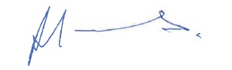  Cllr. Rob Jones  Leader, Neath Port Talbot Council | 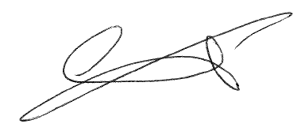  Cllr. Rob Stewart  Leader, Swansea Council
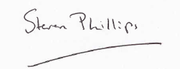  Steven Phillips  Chief Executive, Neath Port Talbot Council | 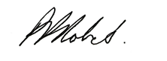  Phil Roberts  Chief Executive, Swansea Council
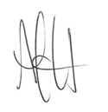  Andrew Jarrett  Director of Social Services Health and Housing, Neath Port Talbot Council | Dave Howes  Director of Social Services, Swansea Council
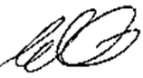
Emma Woollett
Interim Chair, SBU HB

