Write a character description about the baboon.
Think about
What does he looks like? How does he move?
How does he feel? How does he behave?
What does he do? Character traits
I have shared a few ideas below. Remember to use wow words to describe him
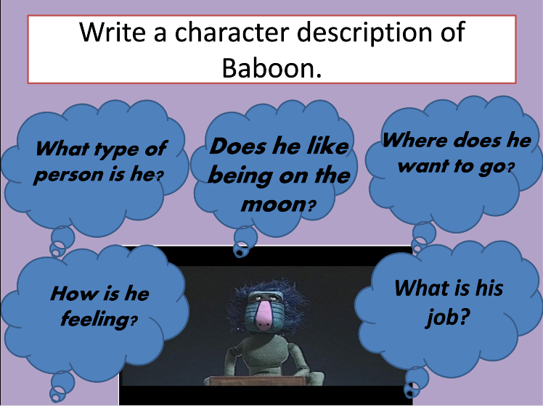
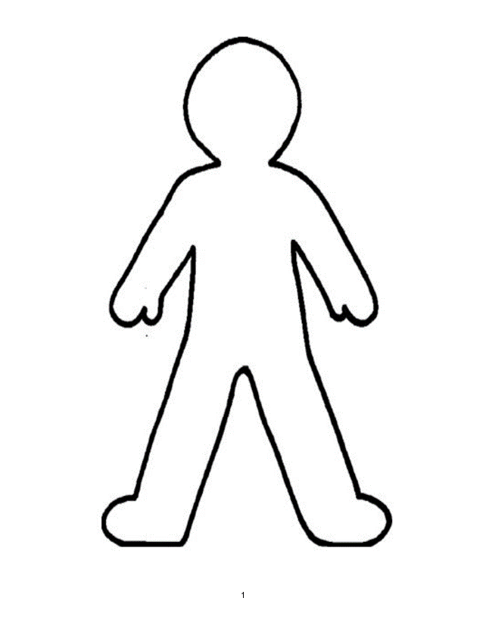
Draw a picture of the baboon in the middle and write about him around the picture.
Ideas below
