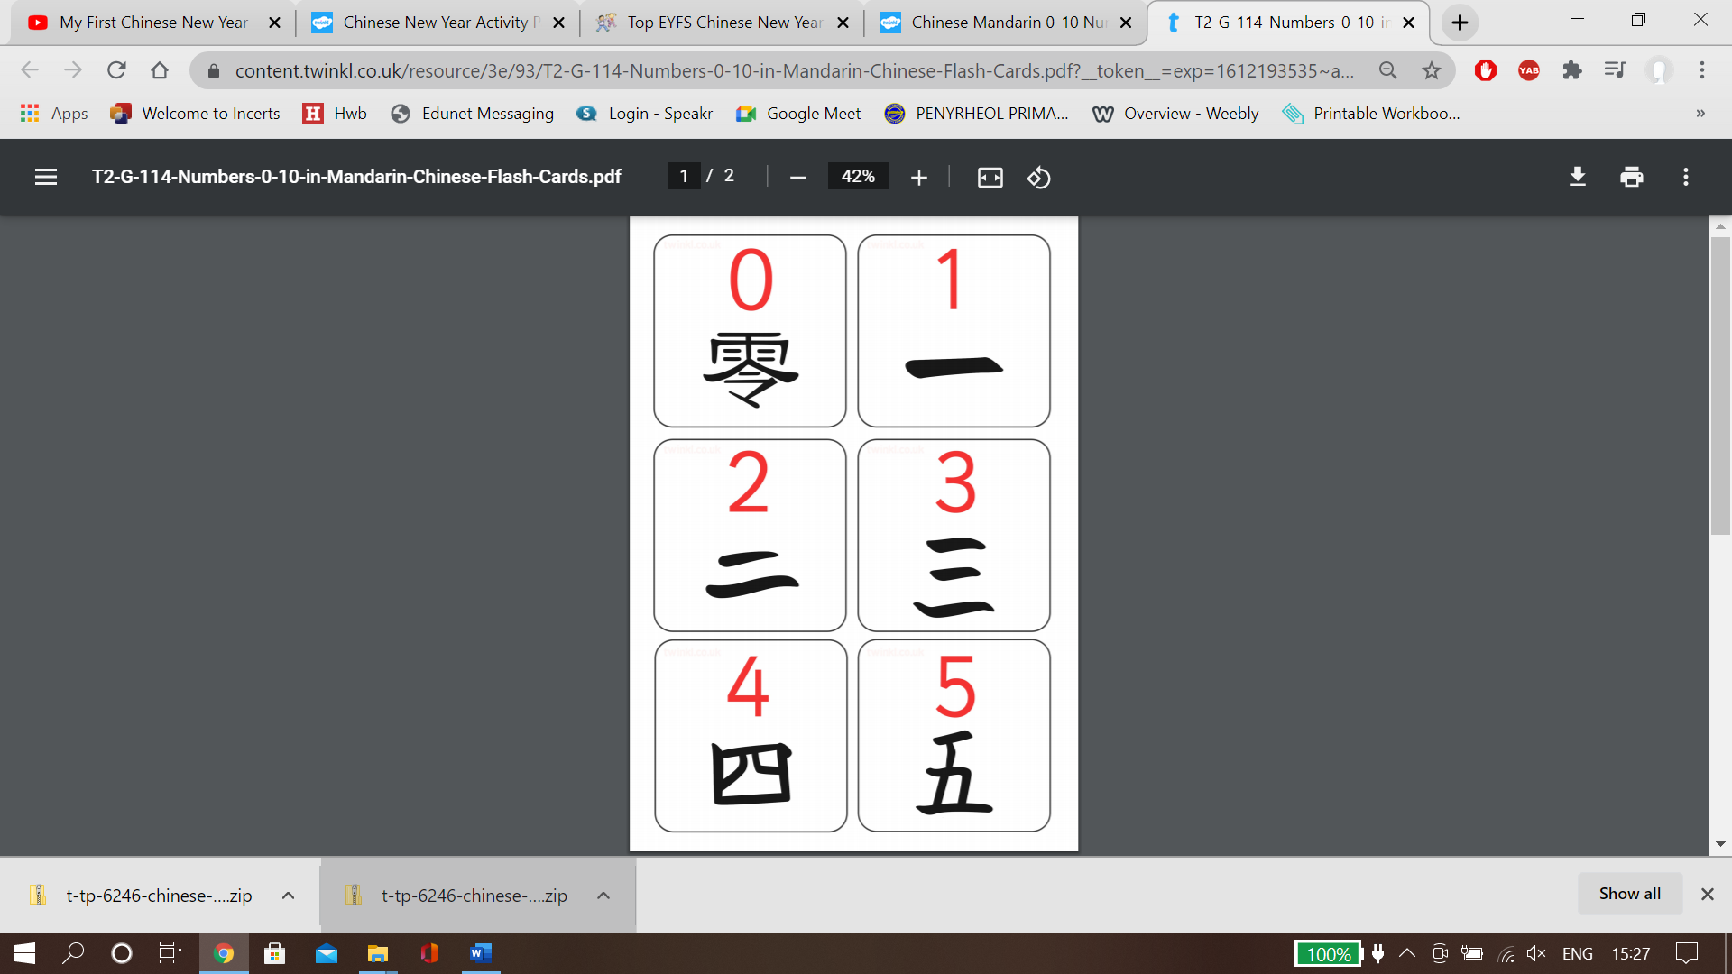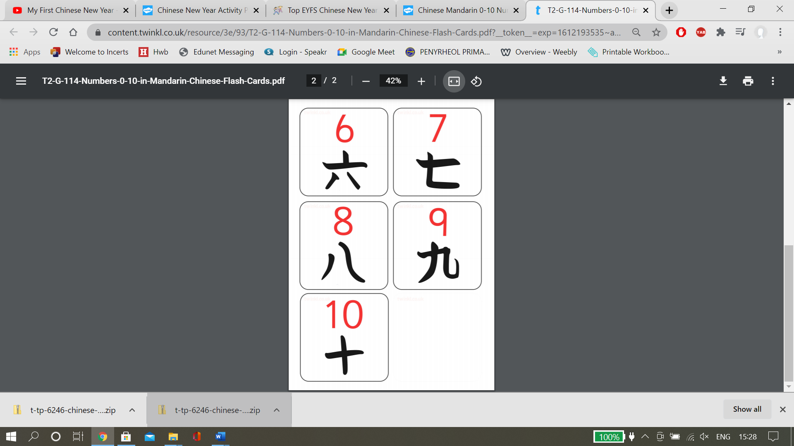

Write the correct code numbers on this blue line.

**Chinese Code Cracking**

**First** I would like you to write your numbers in the correct number order 0 - 10.

**Next** I want you to crack the code. Take a look at the Chinese numbers below and work out the special number code.

**Last** I want you to have a go at using black paint on a separate piece of paper and write the symbol for your age.

Write your numbers 0-10 in this space below: -