What am I?

Use the key to identify these mystery animals. Write the name of each one

underneath their picture.

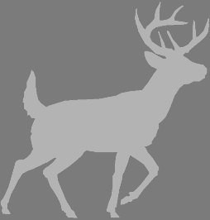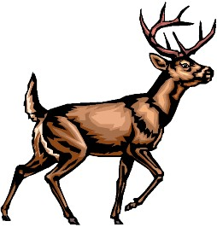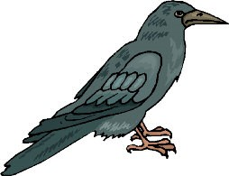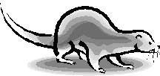

________________

________________

________________

________________

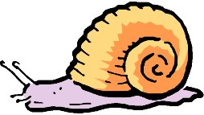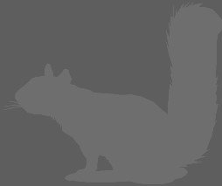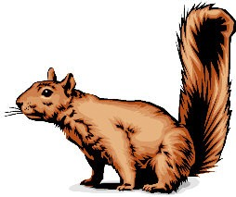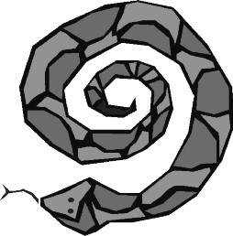

________________

__________________________

________________

**START**

Does it have legs?

YES

NO

Does it have

fins?

Does it have

wings?

YES

NO

Raven

Does it have

antlers?

NO

YES

Fish

Does it have

a shell?

YES

NO

Snail

Adder

YES

NO

Does it have a

fluffy tail?

Red Deer

Red Squirrel

Otter

YES

NO

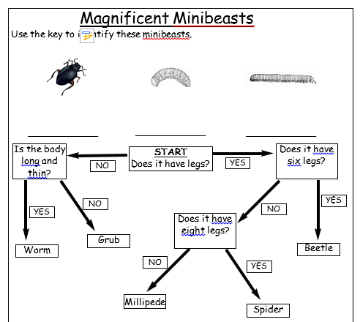

WILF: Use a key to identify an animal or plant

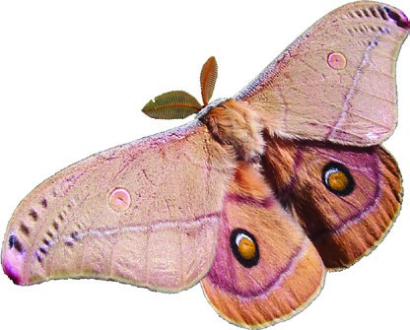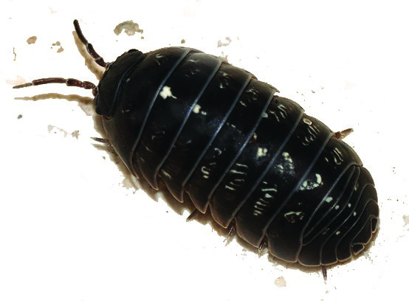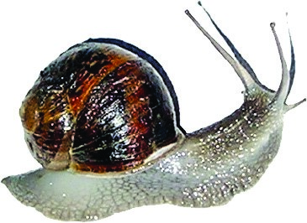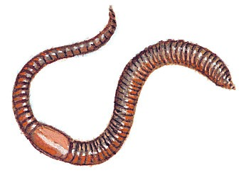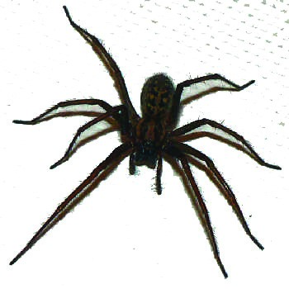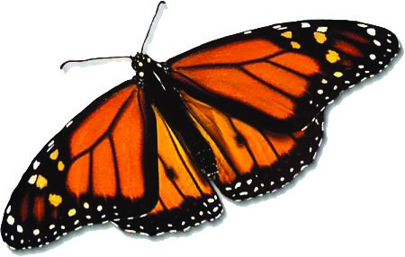

Has the animal got legs?

Has it got wings?

Has it got a shell?

Has it got more

than 8 legs?

Are the antennae

feathered?

**YES**

**YES**

**YES**

**YES**

**YES**

**NO**

**NO**

**NO**

**NO**

**NO**

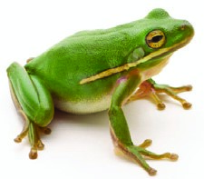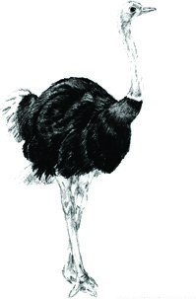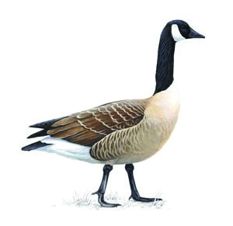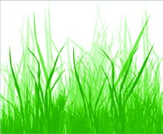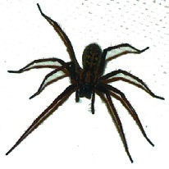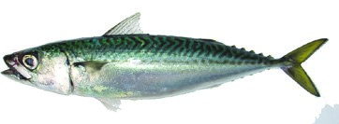

Does it belong in the water?

Does it have wings?

Does it grow in the ground?

**YES**

**YES**

**YES**

**YES**

**YES**

**YES**

**NO**

**NO**

**NO**

**NO**

**NO**

**NO**

**NO**

**YES**