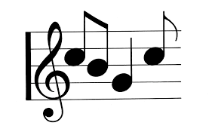
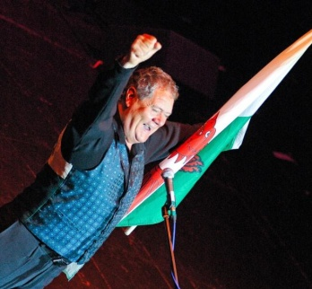
Compare the Songs
 | Max Boyce Version | Harry Secombe Version
Name a place where you think this version would be played.

List the instruments you hear

Describe the musical elements you hear

How does the song make you feel?

‘SWANSEA TOWN’

