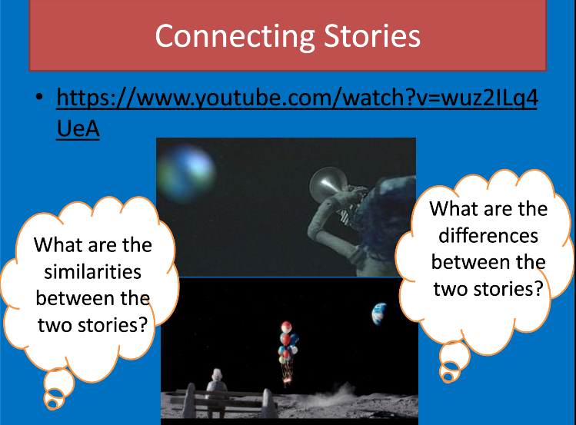

Click here to watch the John Lewis advert – The Man On the Moon.

<https://www.youtube.com/watch?v=jGY-T4W-BOc>

|  |  |
| --- | --- |
| **Similarities** | **Differences** |
|  |  |