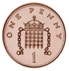
Name _________________ Date_____________

Counting Pennies
Count how much money there is in each bag.

p

p

p

p

p

p

