Activity 8
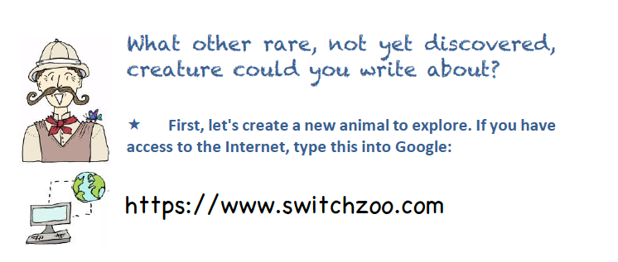
Here, you can create your own creature by blending zoo animals together.

Print off your animal and stick it below. OR you can create your creature yourself. Simply draw into the box below to design a new animal that you might find on land or in the sea.
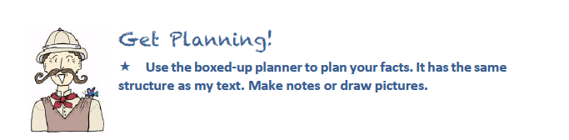

Name of animal
What is it?
Introduce the animal
Appearance
What does it look like?
Habitat
Where does it live?
Diet
What does it eat?
Talents
What can it do?
Fascinating fact

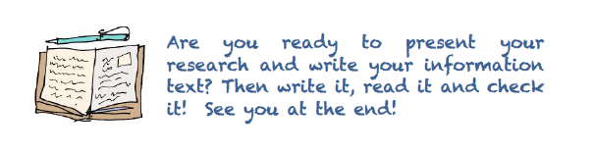

Write an Information text for your made up creature.

