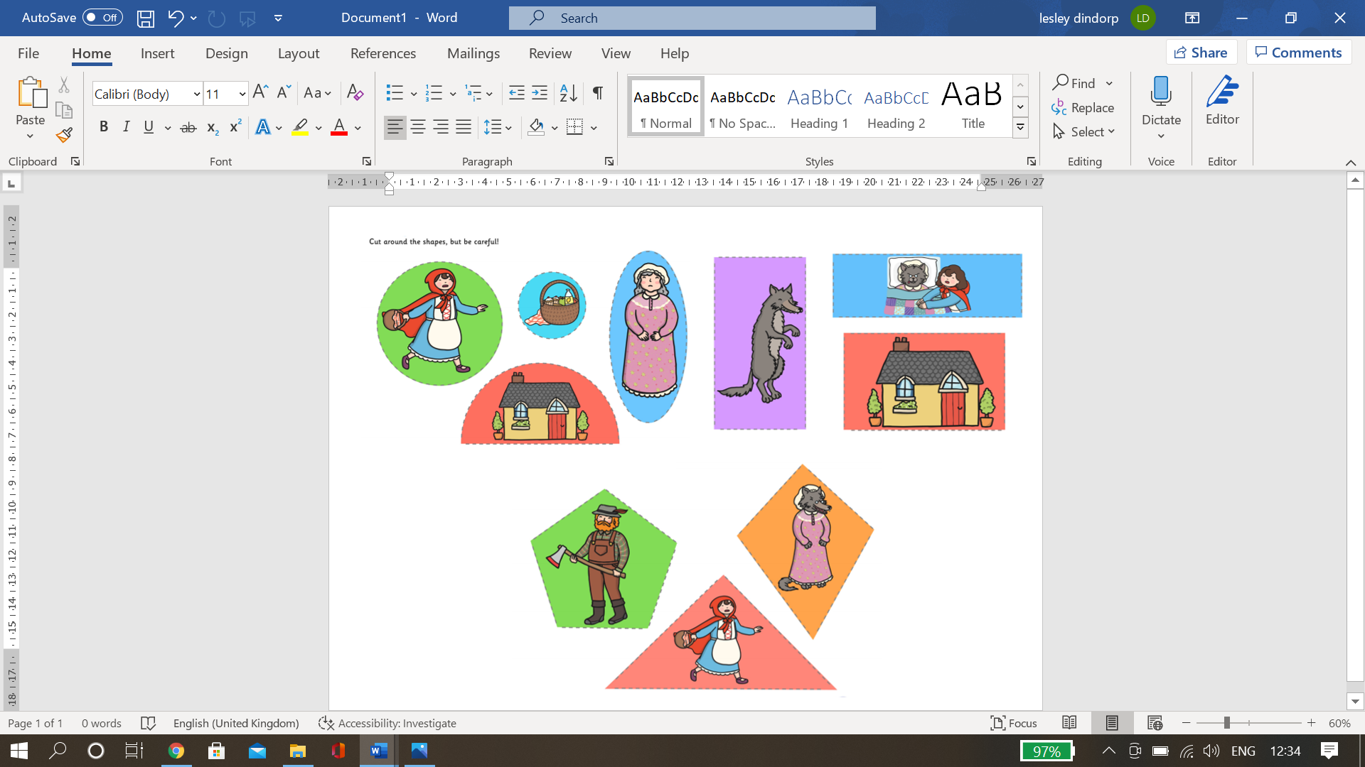

Can you very carefully cut out the shapes and stick them onto a long piece of paper in this order please.

* Shapes with 1 side
* Shapes with 2 sides
* Shapes with 3 sides
* Shapes with 4 sides
* Shapes with 5 sides.