- Read the following diary entry
- Complete task 1- design a planet
- Read Mrs Rimell’s good example
- Complete Task 2- planning ideas and diary entry

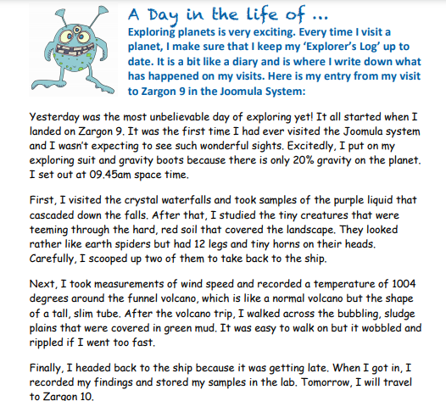

TASK 1:
Draw and design your own planet.. you can present your work whichever way suits your learning… Here are a couple of examples …
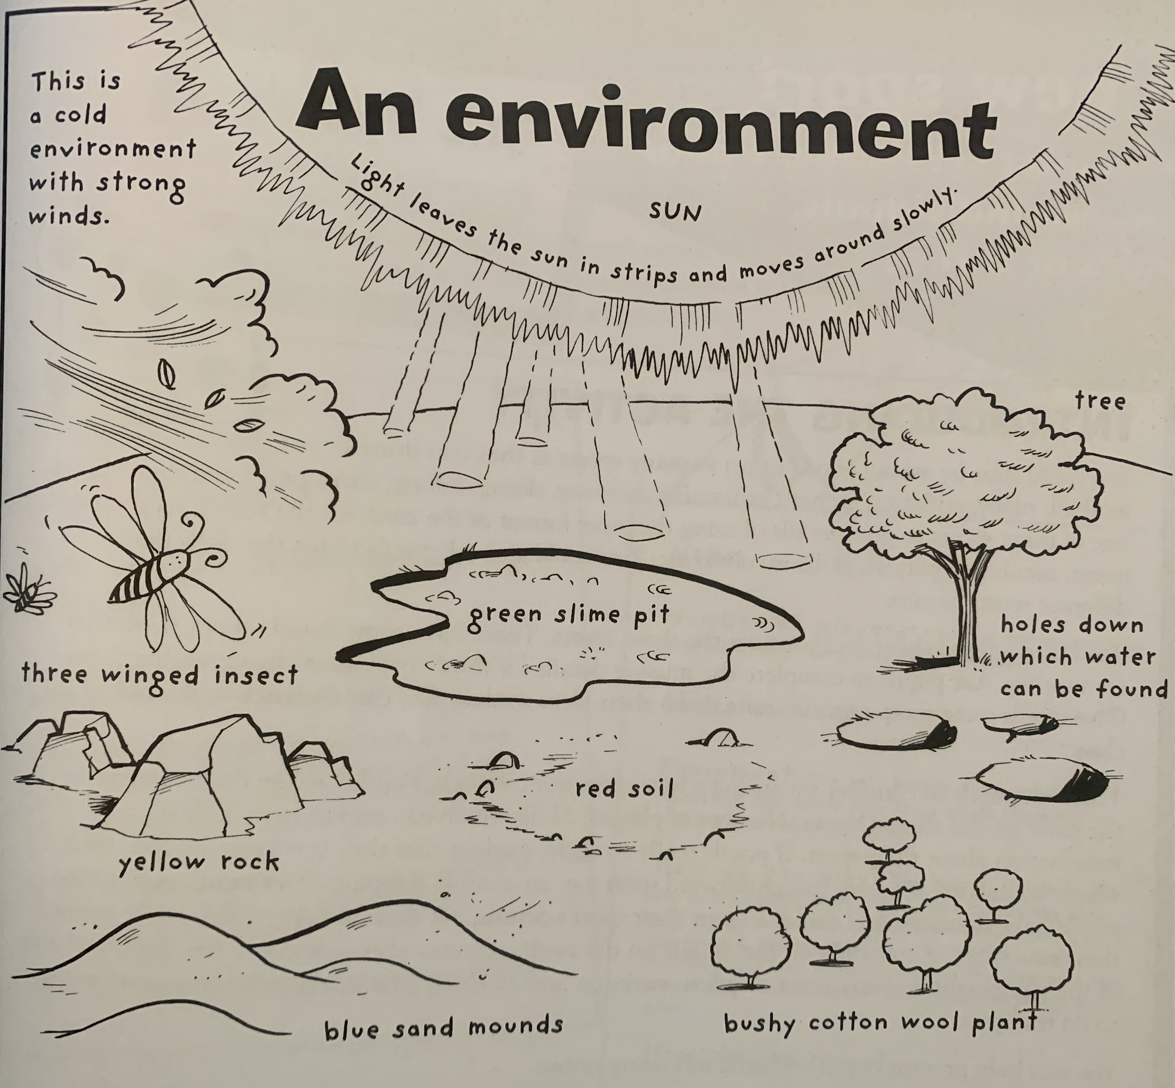

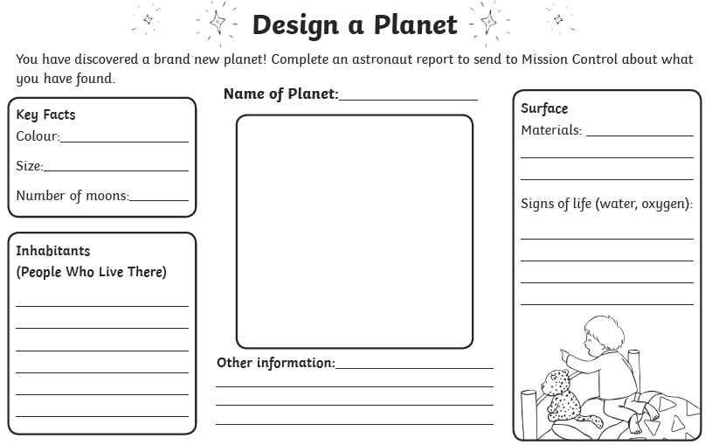

My Invented Planet by Mrs RImell
PLanet Rimell Diary Entry:
26.01.21 at 11.33 am
Saturday was the most fascinating day of exploring yet! It all began when I landed on Planet Rimell. It was the first time I had ever visited the SpakleStar system and I wasn’t expecting to see such inspiring sights.
Frantically, I put on my space goggles and planet puffer coat because there is only 15% gravity on the plant. I set out at 10 am space time. First, I visited the neon light laser forest and measured the glow intensity of each laser beam that strobed from one tree to another. After that, I studied the glow in the dark particles that were hidden through the powdery, violet soil that covered the landscape. They looked rather like hundreds and thousands that you find on earth cupcakes but each particle glowed and flashed each millisecond. Carefully, I scooped up a large sample to take back to the ship. Next, I took measurements of wind speed and recorded a temperature of 2013 degrees around the green slime pit. After that, I shuffled across the rocky, precarious plains that were covered in amber rock fragments. It was dangerous to walk on and the amber dust stained my moon boots. Finally, I headed back to the ship because it was getting late. When I got in, I recorded my findings and stored my samples in the lab. Tomorrow, I will travel to Planet Xion.
Tell you more tomorrow,
Mrs Rimell

TASK 2:
Imagine you have explored your planet that you have just created. Use the same pattern as me and use your planner to jot down some ideas. Once you have planned your work, write it out neatly like I have with my diary entry.


