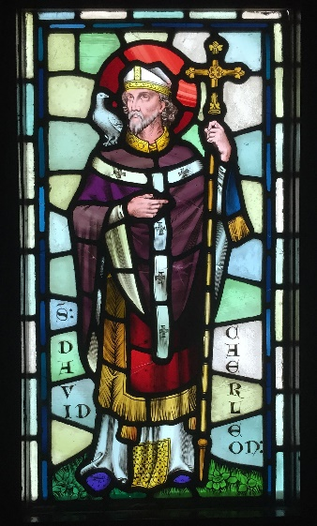
Dewi San – Yn Gywir neu Anghywir?
Correct or Incorrect?

Activate your prior knowledge, and then watch the powerpoint on St. David to see if you guessed correctly – pob lwc!
Ffeithiau / Facts | Cywir/  Correct | Anghywir/Incorrect
David was born in the 20th century on the south-west coast of Wales.
David’s teacher was an old monk called Kevin.
He only ate bread and pizza, he only drank water.
David built a monastery in Glyn Rhosyn, Pembrokeshire.
Every day he worked hard. He pulled the plough whilst farming the land where he grew vegetables.
He read the Bible, prayed and helped the poor.
David preached to one person in the village of Llanddewi Brefi.
The land rose under his feet enabling everyone to hear and see him.
He died on February the 1st, so that is why we celebrate on that date.
We celebrate St. David’s Day every year in memory of him.
David was born on the south-west coast of Wales, near to where the city of St Davids is today.

