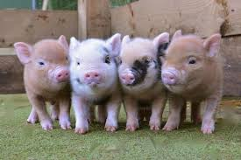
Would a pig make a good pet?
If you could choose any animal to have as a pet, which animal would it be and why? Draw a picture of your chosen pet below and give it a name.
