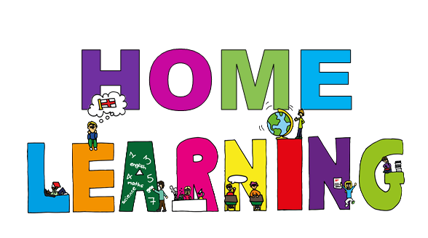

Monday 6th April Dydd LLun 6 Ebrill
Hello everyone! Bore da bawb.

HAPPY EASTER

The Easter holidays have finally arrived. I hope you are all well and have been working hard as well as enjoying the sunshine in your back garden.

During the Easter break, I am going to give you ideas of fun activities you can do with your family.

Ideas for a fun filled Easter.

Egg challenge.

Can you save this egg from getting scrambled?
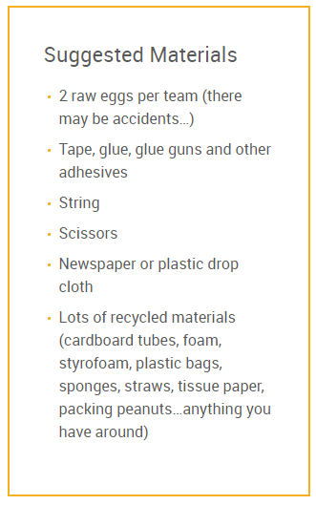
Using a raw egg, what they think would happen if you dropped it on the ground. Do they think you could design some way of preventing the egg from breaking using a range of materials from around your house.

Please take photos and share with me, I can then upload them onto our class webpage.
You could split your family into teams and have groups challenges or your could design and make your own.

Remember to decide as a family the rules.
Think about the height it will be dropped from. Who will drop it. Make sure it is a fait test.

Remember to make a prediction before your start dropping them. Say what you think will happen, which egg will be most protected? Why?

- Egg hunt
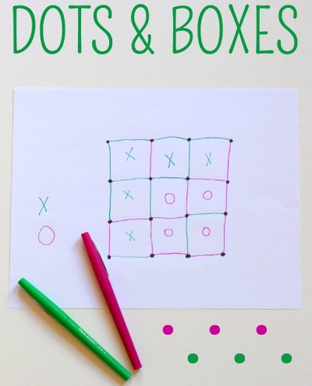
Set up an egg hunt for your family. You could hid eggs around the house and outside. To make it more fun you could give clues for each person to find the hidden egg (treasure hunt). Or you could draw a map to show the location of the eggs. The map would be drawn from a birds eye view (looking down)

- Family games
- Board games ( we have been enjoying connect four)
- Pictionary
- Charades
- Card games
- Egg and spoon race
- Hot potato – you could use an egg, be careful not to break it
- Dots and boxes
- Noughts and crosses

- Get creative
- Design and make an Easter card to send to a loved one
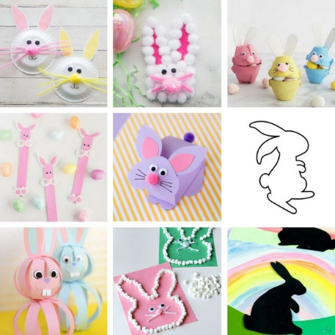
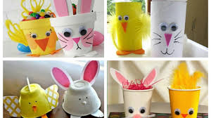
- Easter colouring
- Decorate an Easter egg
- Make an Easter hat/bonnet
- Easter Word search
- Easter baking for example
Easter nests
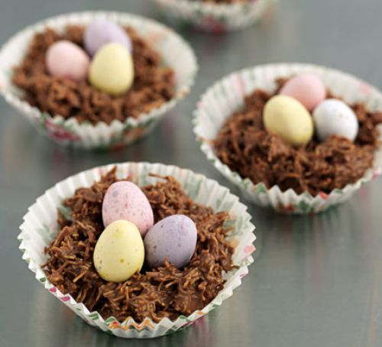
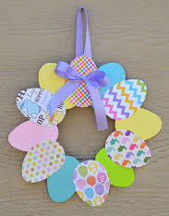

They are just a few ideas for you all to enjoy over Easter. Please send me photos and email me to tell me all about what you have been doing over the Easter break.
Make sure your have fun and enjoy with your family.
Stay safe
Mrs James (jamesr100@hwbcymru.net)

