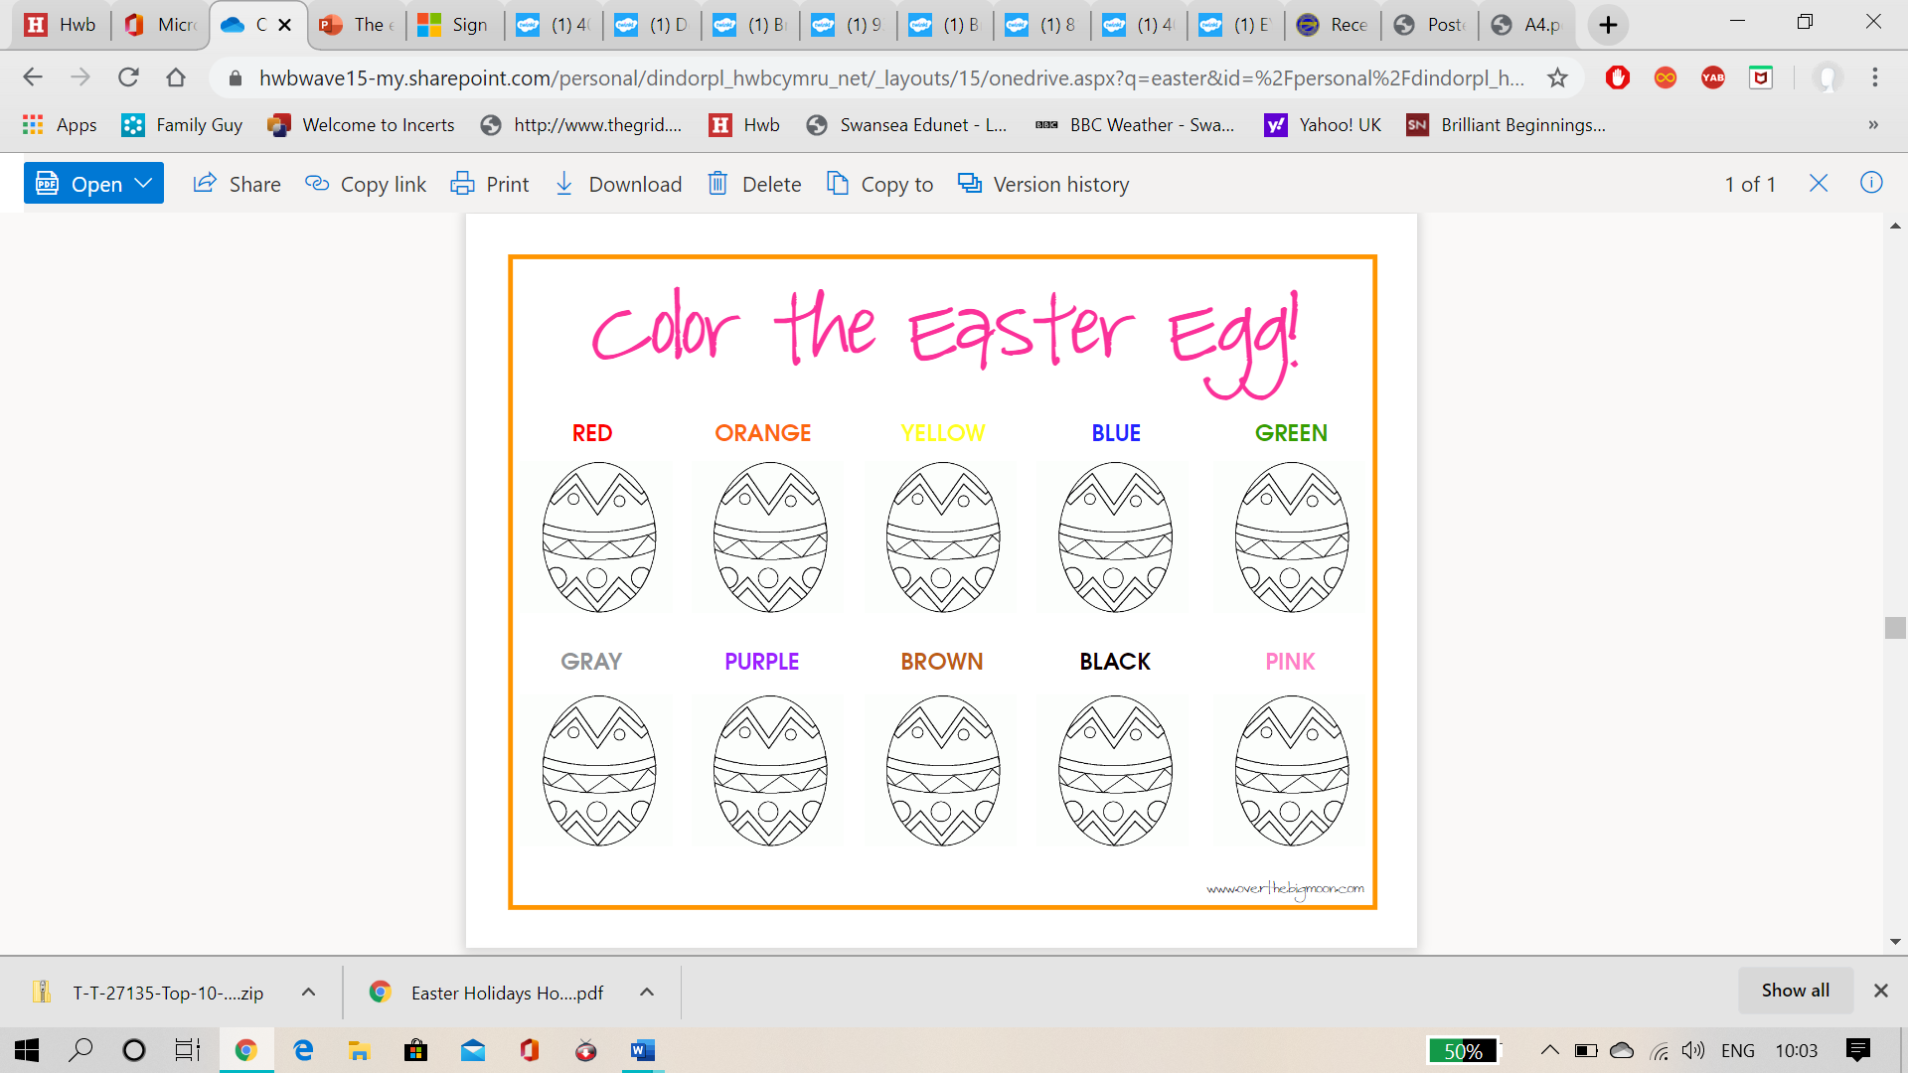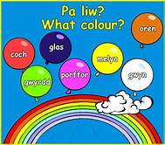

Can you remember singing our Lliwiau Enfys – Rainbow colour

Song? Practice saying and recognising your English and welsh colours. Can you colour in each Easter egg using the right colour?