Create A Lent Plate
Directions: Follow the instructions to make your very own Lent plate
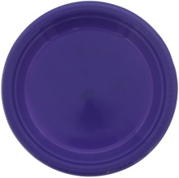
- First, take a paper plate and colour it purple.

- Collect a cup of sand and place this on the plate.

- Put 2 hearts in the sand.
(Either draw these or use beads)

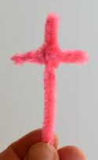

- Make a cross (using sticks, straws or pipe cleaners).
Bluetack or Cellotape this to your plate.

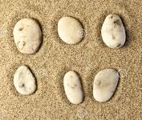
- Collect 6 stones.
Put one stone on your plate on each of the 6 Sundays in Lent.

When completed, your lent plate will remind you of the journey Jesus took and what he gave up for 40 days and 40 nights.

It may remind you to do something good each day too!

