Extra ideas
- Find out about spacesuits https://www.nasa.gov/audience/foreducators/spacesuits/home/clickable_suit.html
Now design clothing for space travel/ space suit

- Design a healthy meal for an astronaut - link to healthy plate we looked at recently.
- MUSIC
Listen to Gustave Holst – The Planets https://www.youtube.com/watch?v=Isic2Z2e2xs
Spooky space sounds https://www.nasa.gov/vision/universe/features/halloween_sounds.html

- Create a dance to Spooky space Sounds / the Planets

- BBC bitesize links
https://www.bbc.co.uk/bitesize/clips/zd4g9j6
https://www.bbc.co.uk/bitesize/clips/zjbvr82 - what it’s like to be an astronaut

- Neil Armstrong video https://www.bbc.co.uk/teach/class-clips-video/ks2-neil-armstrong/zr9tjhv

- Get baking – bake space cookies or biscuits They could be star, rocket or planet shaped. They could even include space rocks such as popping candy!

- Thinking time
- You are going on a spaceship and can only take 10 things with you. What will you take? Either write or draw them in your suitcase.

- You are going to meet some aliens on another planet. What 10 things would you take as presents for them? Draw them in a gift box.

- Keep a sky at night journal for a whole week.
Write about everything you can see in the sky. You could draw a picture of the moon every night. Does it change over the course of the week?

- Design an alien (look to the natural word for features) and create an alien mask.

- Create a new mnemonic that will help others remember the names of the planets and their order from the sun.
You will use the first letter of each planet (in the correct order) to make up a sentence to help someone remember the order of the planets. Below are some examples.

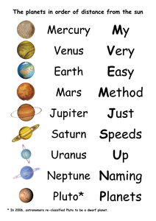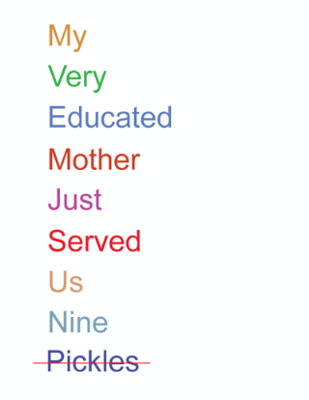

- Check out this app http://amazingspacejourney.com and explore this app.
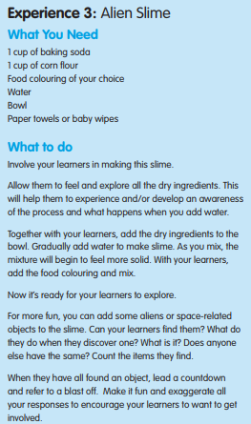
- Make alien slime
- With father’s day on Sunday, make a card for a loved one.

