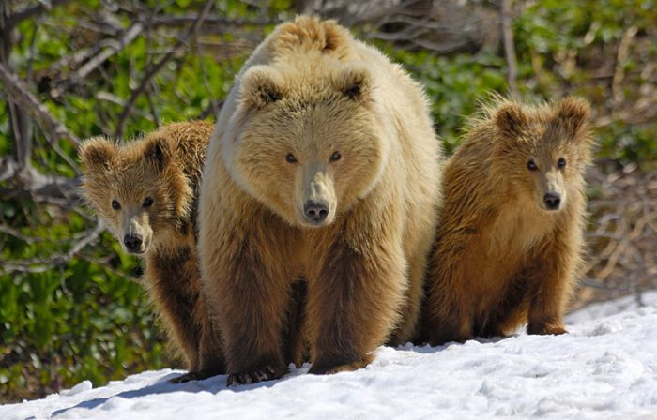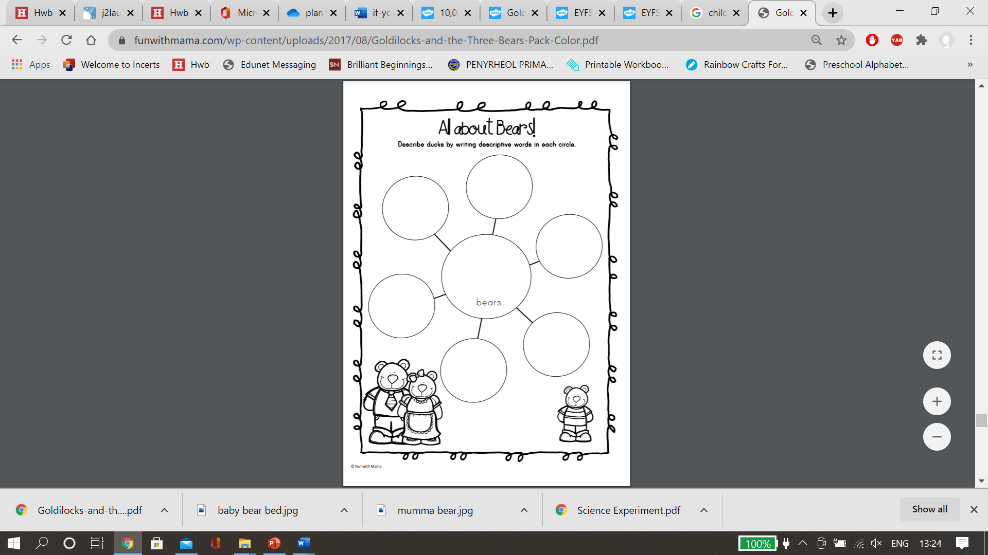

Where do bears sleep?

What do bears eat?

Find out about bears using books or the internet. Use pictures, drawings, or words to record what you discover.

What does a bear look like?

Can bears swim?

When do bears like sleep?

Where do bears live?