T is for tiger

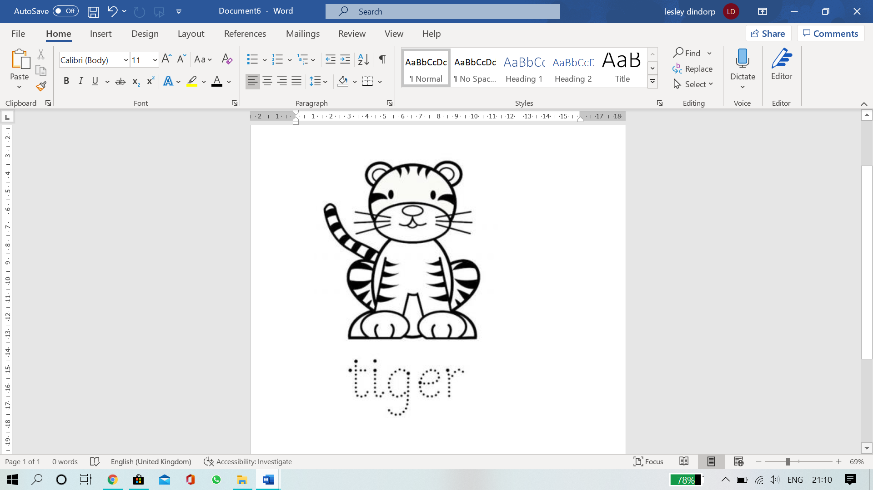Can you find out?

Do tigers like water?

What

Where do tigers live?

What

What do you call a baby tiger?

What

What pattern is on my fur?

What

What do tigers eat?

What colour is a tiger?