FIREWORKS IN A JAR
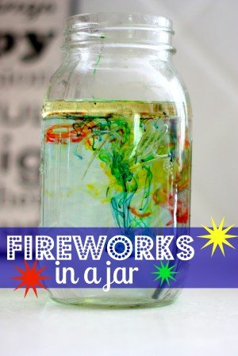

If you have a little one who is fascinated with colours and fireworks, this simple experiment is for you (and your child).
You will need: oil, water and food colouring!

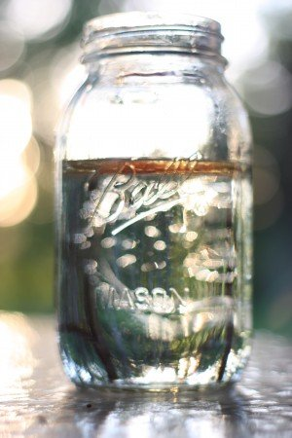
1. Fill your jar 3/4 of the way full with warm water.
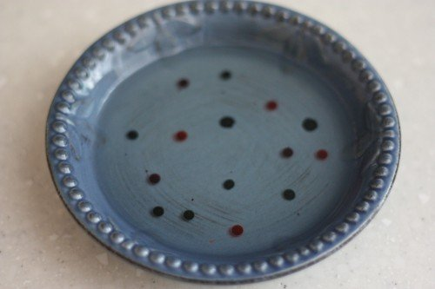
2. In a separate bowl, mix a 3-4 tablespoons of oil and several drops of different colours of food colouring (I used 4 drops of each colour: red, yellow, blue, and green).
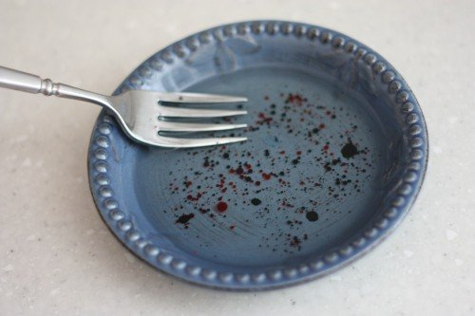
3. Use a fork to gently mix the oil and food coloring together.
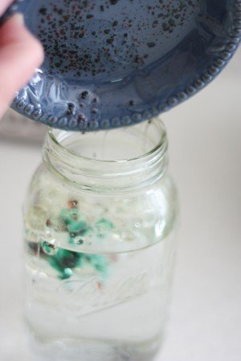
4. Gently pour the oil mixture into the jar.
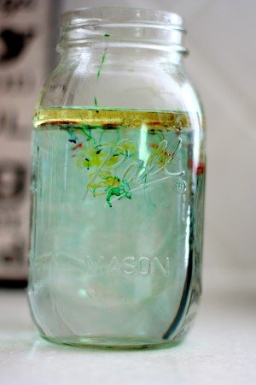
5. Watch what happens—the food colouring will slowly sink out of the oil and into the water. When this happens, it will expand and begin to mix with the other colours.
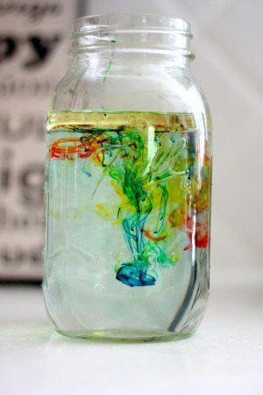
The Science Behind It:
Food colouring dissolves in water but not in oil. Because the oil is less dense than the water, it will float at the top. The coloured droplets will begin to sink because they are heavier than the oil. Once they sink into the water, they will begin dissolving into the water (which looks like a tiny explosion).

