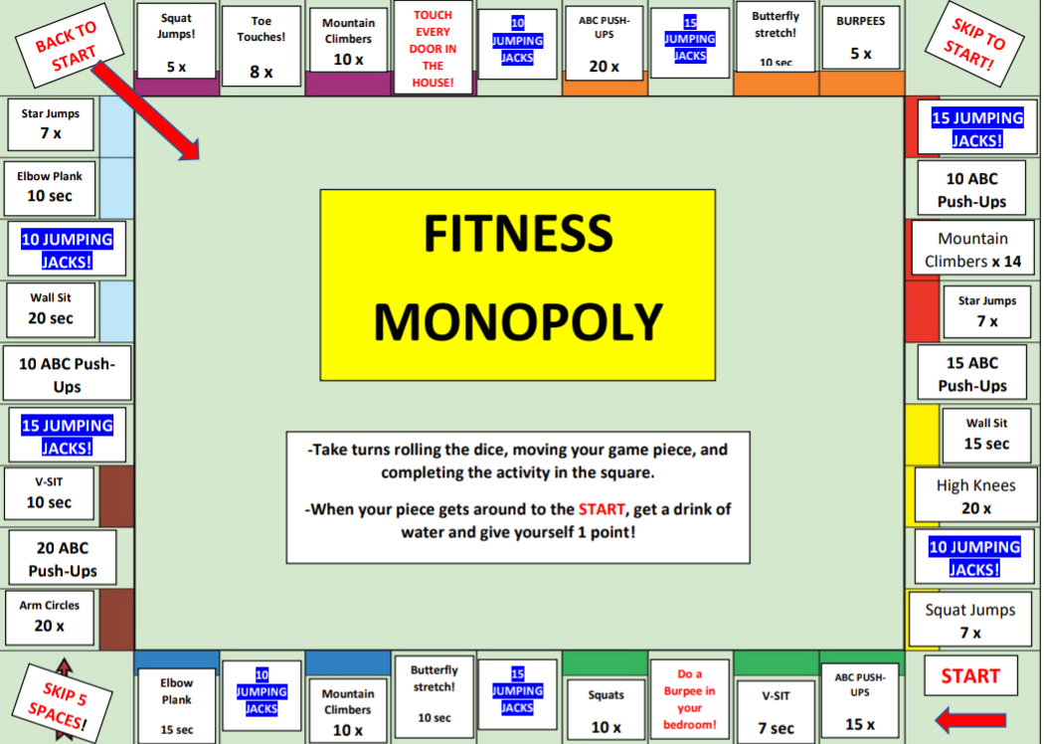
Squat Jumps!
BURPEES
Toe Touches!
Butterfly stretch!
ABC PUSH
UPS
Mountain Climbers 10 x
TOUCH EVERY DOOR IN
THE HOUSE!
BACK TO
START
SKIP TO START!
JUMPING JACKS
JUMPING JACKS
5 x
5x
10 sec
8x
20 x
Star Jumps
7x
15 JUMPING
JACKS!
Elbow Plank
10 sec
10 ABC Push-Ups
10 JUMPING
JACKS!
Mountain Climbers x 14
FITNESS MONOPOLY
Star Jumps
Wall Sit 20 sec
7 x
10 ABC Push
Ups
15 ABC Push-Ups
15 JUMPING
JACKS!
Wall Sit 15 sec
-Take turns rolling the dice, moving your game piece, and
completing the activity in the square.
V-SIT 10 sec
High knees
20 x
- When your piece gets around to the START, get a drink of
water and give yourself 1 point!
20 ABC Push-Ups
10 JUMPING
JACKS!
Arm Circles
20 x
Squat Jumps
7x
Butterfly stretch!
START
SKIP 5 SPACES!
Elbow Plank
ABC PUSH
UPS
JUMPING JACKS
JUMPING JACKS
Squats
Mountain Climbers
10 x
Do a Burpee in
your bedroom!
V-SIT
10 sec
15 sec
10 x
7 sec
15 x

