All animals and plants need food to grow and move.
Animals that eat plants are called herbivores.
Animals that eat other animals are called carnivores.
Animals that eat both plants and animals are called omnivores.
- Using your research complete the table below
Name of minibeast | Herbivore | Carnivore | Omnivore
Pond Snail
Water Flea
Leech
Water Boatman
Water Louse
Tadpole
Freshwater Shrimp
Pea Mussel
Mayfly Nymph
Dragonfly Nymph
Bloodworm
Flatworm
Water Mite

All animals and plants depend on each other for food and these relationships are called Food Chains or Food Webs.
- Fill in the spaces in the Pond Food Chain that is drawn below.
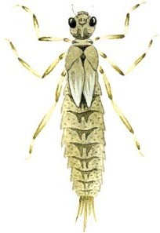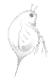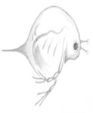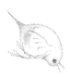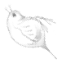

Dragonfly nymph
eats the _ _ _

Water fleas eats
the pondweed

_ _ _ eats the
Dragonfly nymph

- Draw a food chain using of one or more of the pond minibeasts that you have found. You can use larger animals such as frogs or birds in your food chain if you need to but you must use at least one minibeast

