6
Food Chains
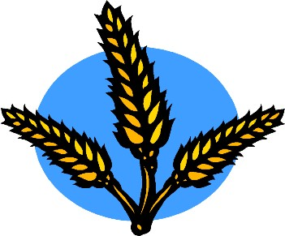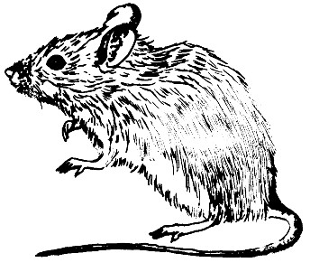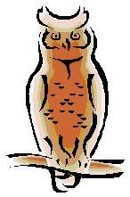
This is a food chain:
wheat
mouse
owl
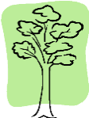
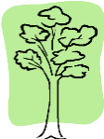
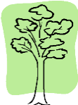
The arrows mean is eaten by. The wheat is eaten by the mouse. The mouse is eaten by the owl.
All food chains begin with a green plant. Plants produce their own food using energy from sunlight. They are called producers.
Animals can’t make their own food in the way that plants do. They have to get their food by eating plants or eating other animals. Animals are consumers. An animal which eats another animal is a predator. The animal which gets eaten is its
prey.
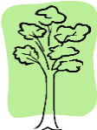
A food chain shows what eats what. It will begin with a green plant, a producer, which will be eaten by a plant-eating animal, a herbivore. This is a consumer.This animal
will be eaten by another animal, a meat-eater or carnivore. This is also a consumer.

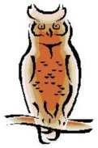
Extra fact:
You may sometimes see the first animal (the plant-eater) in the food chain called the primary consumer and the second animal (the meat-eater) in the food chain called the secondary consumer.
Extra fact:
Animals which eat plants and also eat other animals are called omnivores.
Humans are omnivores: we eat plants but we also eat meat.
See Activity Sheet 7 for work on food chains.
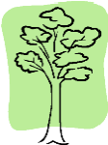
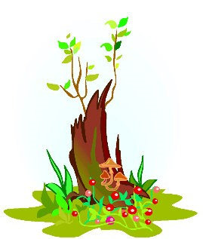
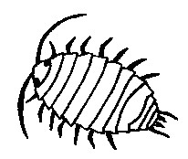
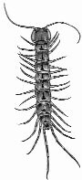
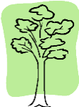
Habitat Investigation - ⁷ Woodland Minibeasts

Minibeasts can be found throughout the woodland, living on trees and bushes, and in the leaf litter on the ground. Minibeast habitats also include any plant, underneath
rocks and in cracks in walls, so you can even find some in your school’s garden or playground.Typical woodland minibeasts might include:
Leaf Litter Bushes spiders aphids ants bush crickets slugs spiders
worms shield bugs grubs caterpillars beetles flies woodlice moths
centipedes butterflies millipedes ladybirds

Extra fact:
Minibeasts are good indicator species for the richness of a woodland habitat. If there are lots of minibeasts, there must be lots of plants for them to feed on and there will also be lots of animals which eat the minibeasts.

Minibeast Food Chains
This is a typical minibeast food chain. Most food chains start with a green plant.
However, many minibeasts will eat dead and rotting plants and so their food chains will start with these. Naturally, many minibeasts such as aphids, caterpillars and bush crickets do eat green plants and are classed as herbivores.
rotting wood woodlouse centipede
Extra fact:
Dead and rotting plants are not producers. They are called detritus and the animals which eat them are called detritivores.
See Activity Sheets 5 and 6 for work on minibeasts.

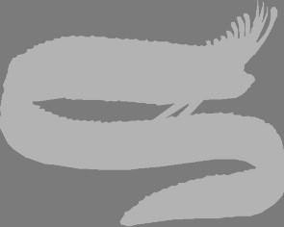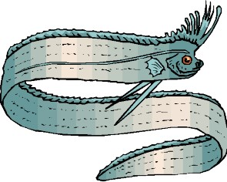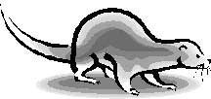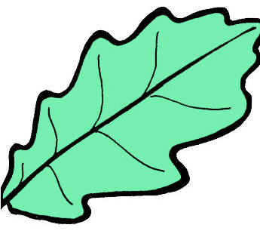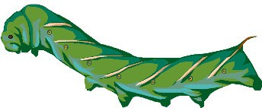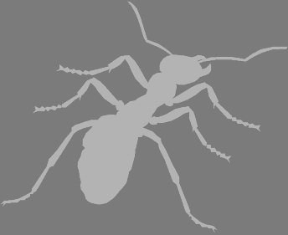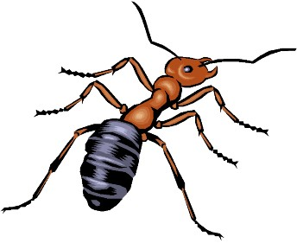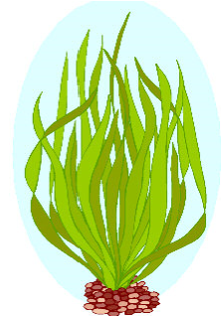
Food Chains
Write these food chains in the correct order. Then write the name of one
producer, one predator and one prey in each food chain.
...................................

............................... ......................................
Producer................................... Prey...................................... Predator...........................................
............................... ...................................... ...................................
Producer................................... Prey...................................... Predator...........................................
wheat
mouse
owl
............................... ...................................... ...................................
Producer................................... Prey...................................... Predator...........................................
seaweed
otter
eel
ant
caterpillar
leaf
