Geometric birds!
Look carefully at the bird below. What different shapes can you see?
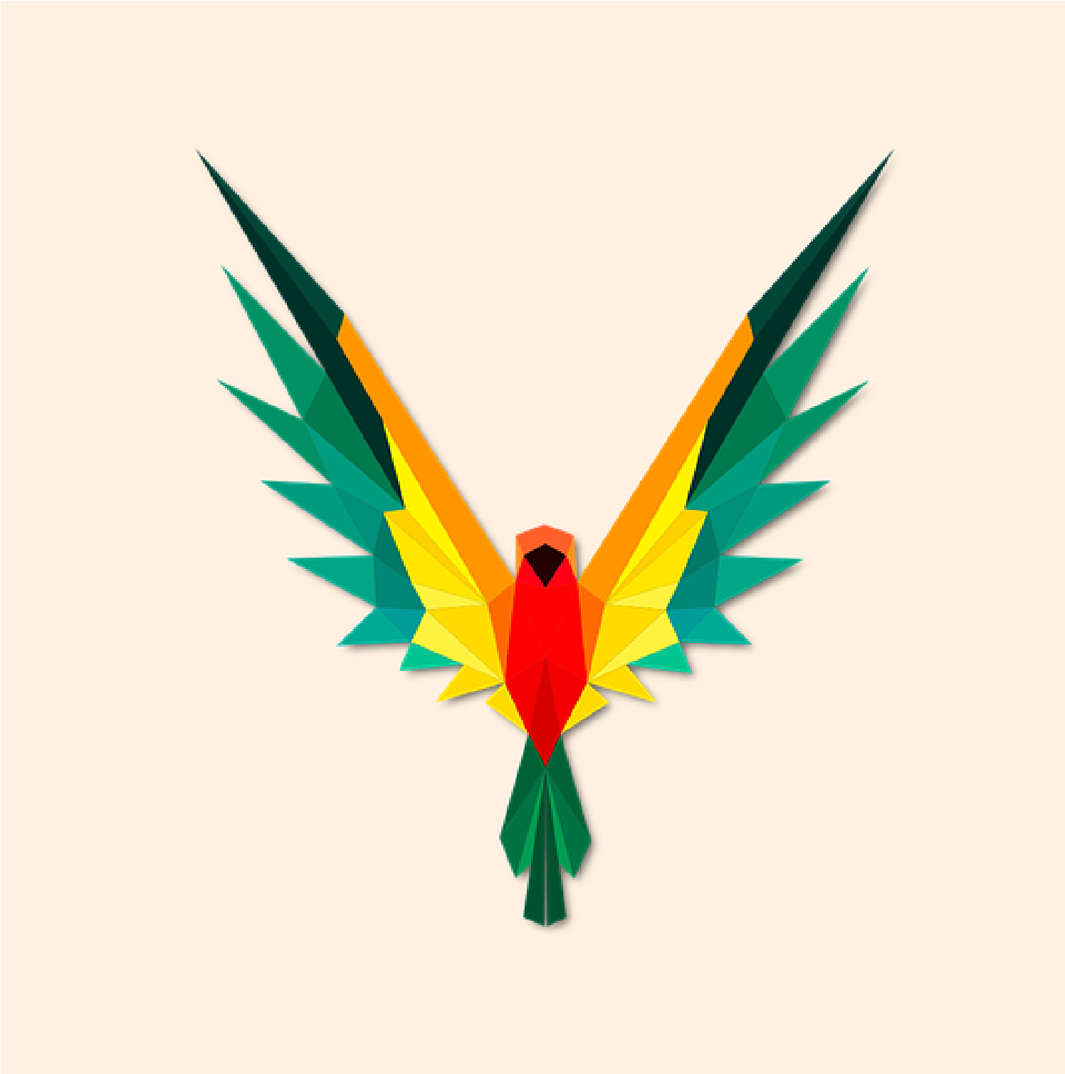
Most of the bird is made up of triangles (right angled, isosceles and scalene).Can you see that the long orange shapes on the wings have four sides (quadrilaterals). There are other quadrilaterals on the birds face too.
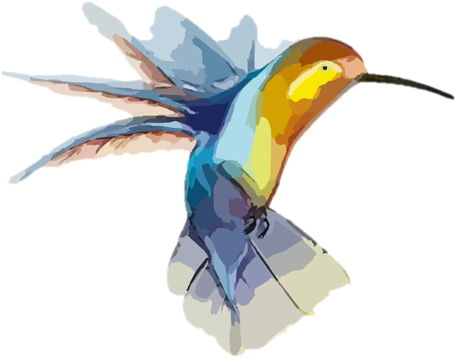
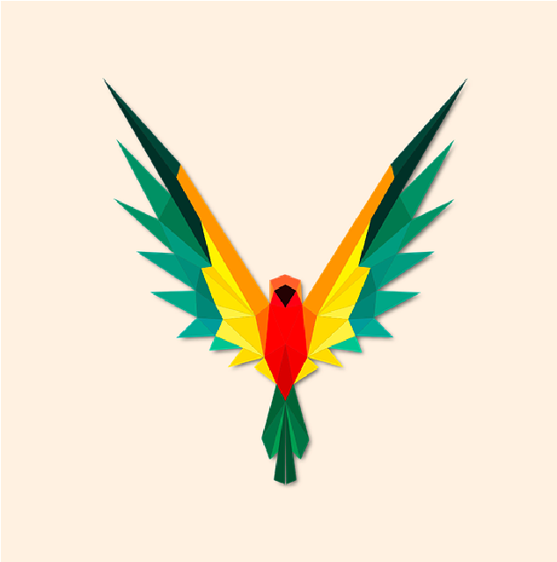
Geometric birds!
Have a go at creating your
own geometric colourful
bird made using triangles
and quadrilaterals:

