Here is an example of a secondary school timetable. Look carefully at the timetable, read the information underneath and then answer the questions.
Day of the Week | Session 1  9.00 – 10.00 | Session 2  10.00 – 11.00 | Break | Session 3  11.20 – 12.20 | Session 4  12.20 – 1.20 | Lunch  1.20 – 2.00 | Session 5  2.00 – 3.00
Monday | PE | Maths |  | English | Science |  | History
Tuesday | R.E | Food Technology |  | French | Art |  | English
Wednesday | Science | Maths |  | Maths | Geography |  | Technology
Thursday | French | English |  | P.E. | Maths |  | Geography
Friday | Science | Art |  | Maths | History |  | PE
- When you are having a packed lunch, you will need to remember to take it with you.
- When you are having a school dinner, you need to make sure you have enough money in your account.
- You need to make sure you arrive in school on time. School starts at 8.40 a.m.
- For food technology, you need to take in the ingredients you need to make your food.
- For PE, you need your PE kit.
- For every other lesson, you need to take your homework in.
- For all lessons, you will need your planner.
Use the information you have to answer the questions below. Think about which lessons you have and what else you might
need for the day.
- It is Monday tomorrow. What do you need to pack into your school bag? ____________________________________________________________________________________________________________________________
____________________________________________________________________________________________________________________________
- It is Thursday tomorrow. What do you need to pack into your school bag? _____________________________________________________________________________________________________________________________
_____________________________________________________________________________________________________________________________
- It is Friday tomorrow. What do you need to pack into your school bag? _____________________________________________________________________________________________________________________________
_____________________________________________________________________________________________________________________________
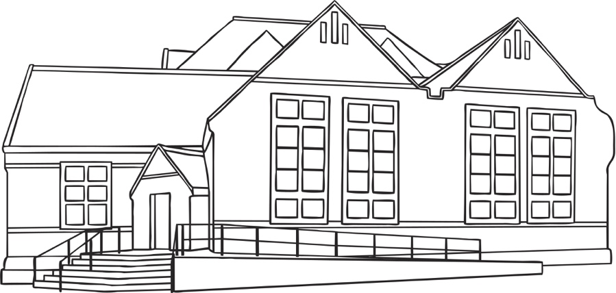
- It is Tuesday tomorrow. What do you need to pack into your school bag? ____________________________________________________________________________________________________________________________
______________________________________________________________
______________________________________________________________
______________________________________________________________

Thinking about times.

- What time does the school day start? ____________________________________________________________________________________

- What time will you need to leave your house to arrive on time? ______________________________________________________________

- What time does Session 4 start? _______________________________________________________________________________________

- When you arrive in school, you will go to your form room to check in (registration). Registration begins at 8.40 a.m. How long until the first
Session begins? ____________________________________________________________________________________________________

- What time will you need to return from lunch ready for Session 5? ___________________________________________________________

- What time do you go home? _________________________________________________________________________________________

Getting to the comprehensive.
Think about how you will get to the comprehensive school. Draw the route you will take on the map on the next page.

