Go on a Take Notice Journey
(Teachers/Parents note)
LO: To explore your local area and see what new things you can notice by using your 5 senses
Objective of Activity:
To have less screen time and have an active journey. To use senses to connect to local areas and relax and re-centre the mind on a mindfulness walk.
This can be a done on a daily journey like a dog walk or a bike ride or scooter ride. Or can be a special journey to take some time to have a break away from screens.

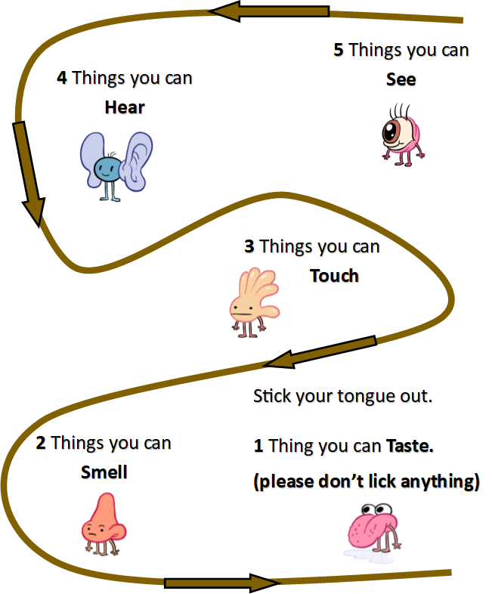
amser i gael seibiant i ffwrdd o'r sgriniau.
Take Notice Journey
Go for a journey with your family and at 5 different places use a different sense to explore on your walk and see what different things you can notice on your journey. This can be done on a walk, bike or scooter ride but only when you stop.

